LAMPS
NIGHT SKY - Pre-wired lighting system

Application
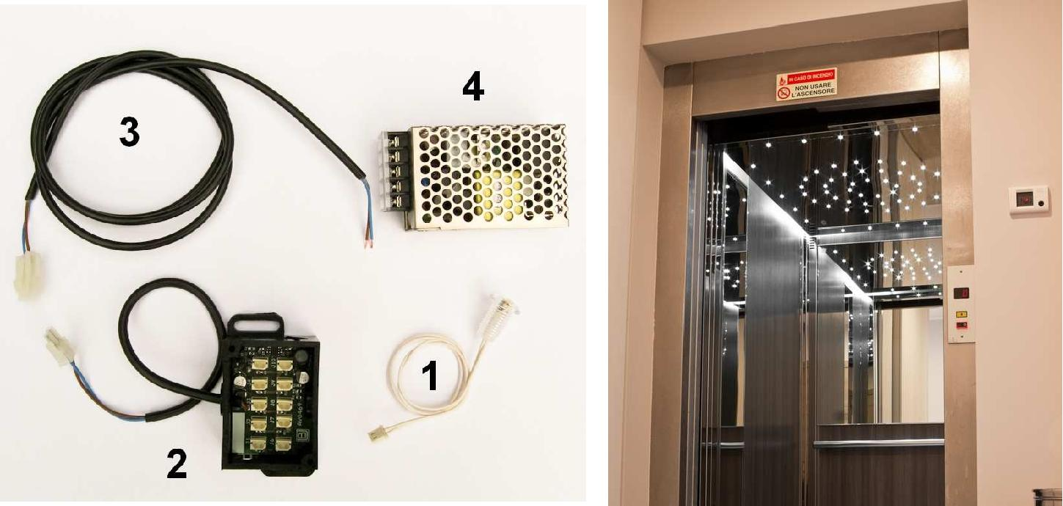

“NIGHT SKY”, Pre cabled lighting system

This pre cabled connection system made the installation and the lift car lighting system maintenance fast and easy.

In order to have a floor lighting according to the energy/safety regulation (50 Lux) usually are necessary about 20 stars every square meter, it depends on the insertion wheelbase and on the materials used in the construction.

Technical specifications

- It allows the construction of “night sky” with various formats and designs.

- The assembly is easy, and can be performed also by no skilled workers.

- Labour cost drastic reduction.

- Easy count of the stars needed and of their final cost.

- Easy maintenance.

- “Stars” dust protection.

Models | Description
LCS1W45 | Feedthrough led star, neutral white light, output on connector - Power consumption from 0,3 W, to 12 Vdc
LCS2W45 | Screwable led star, neutral white light, output on connector - Power consumption from 0,3 W, to 12 Vdc
AV0469 | Concentrator 10 IN + 1 OUT 30cm | - it is necessary a concentrator every 10 Stars
AV0424 | 1200 mm extension, 1 connector - | it is necessary an extension every concentrator.
AV0438 | Power supply IN 230 Vac - OUT 12 Vdc (25W) - for a maximum of 60 Stars

Binding Union srl – via Cuorgnè, 21 – 10156 Torino – Italy – tel. +39.011.2625414 – Fax +39.011.2625428 –www.binding.it – 17

LAMPS
MATTONELLA - LED lamp for interiors, with emergency

Application
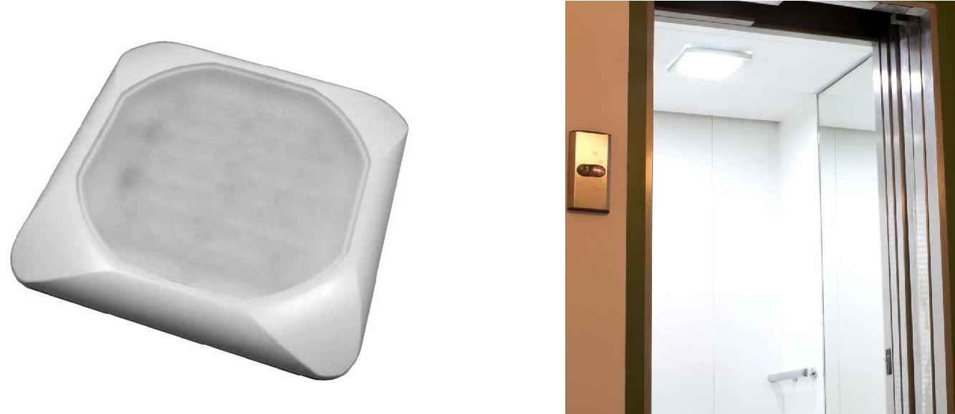

MATTONELLA, LED lamps, with control circuit and external battery charge

Elegant plastic frame. Wide angle intense and uniform lighting. Double lighting modality: complete and emergency. Neutral white light, suitable for lift cars (one lamp is enough to light according to the energy/safety regulation a 100x140 cm surface). They are also excellent for goods lift, recs and engine rooms. Control circuit and external battery charger (optional).

Technical specifications Dimensions

• Double lighting circuit (complete and partial)
- Low power consumption: 10 W complete (1 W partial)

- Neutral white light (4000 °K)

- Emission angle: 120°

- Power supply: 12 or 24 Vdc or 230 Vac

- Light intensity: 300 Lux at 1 m (82 Lux at 2 m)

- Protected against power surges

- Dimensions: 290 (A) x 290 (A) x 30 mm (B)
• Control circuit and external battery charge (CB option)

- Operative life: 30.000 hours at 25°C

Lamp functioning with “CB” option Lamp functioning with “AV0471” accessory
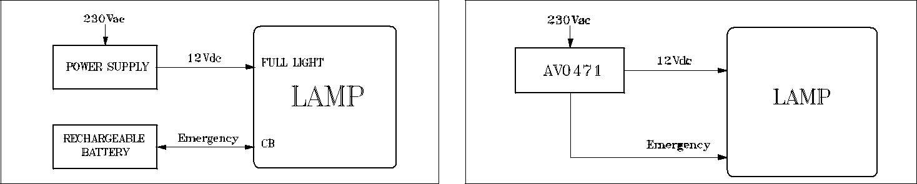

Models Description Models

Description

LMT29FW40 | LED Lamp, 12 Vdc, white case | G | Grey case (Silver)
LMT29GW40 | LED Lamp, 24 Vdc, white case | CB | Control circuit and external battery charge (12 Vdc – 1,2 AH)
LMT29AW40 | LED Lamp, 220 Vac, white case | AV0471 | Buffer battery with incorporated automatic battery charger (12
 |  |  | Vdc, 1,3AH).
S | Protection treatment IP65 | AV0476 | Battery :12 Vdc – 1.3 Ah – Dimensions 96 x 57 x 42 mm

Binding Union srl – via Cuorgnè, 21 – 10156 Torino – Italy – tel. +39.011.2625414 – Fax +39.011.2625428 –www.binding.it – 18

LAMPS
POWER SUPPLY

Installation example
AV0471
L N -V +V +VE
Emergency light

FULL LIGHT

Buffer battery with incorporated automatic battery charger

The emergency ballast, complete with its battery, ensures the continuity of operations to the applied load (e.g. emergency light) when the main power supply is interrupted (blackout due to storms or other reasons).
When the outage occurs, the emergency ballast acts immediately and automatically, providing sustained power supply to the equipment connected to it.

Technical specifications

- Rechargeable lead battery: 12 Vdc, 1.3 Ah

- Estimated operating life: ≥ 3 years

- Power supply: 100…240 Vac 0.7 A – 50/60 Hz

- Output voltage (Vout): (-V…+V) 12 Vdc – 2 A

- Emergency voltage: (-V…+VE) 12.5...13.8 Vdc

- Max Output load: 0.5 A, i.e. 6 W, protected with self-healing fuse

- Nominal duration of operation in emergency: 3 hours with a load of 3 W

- Protection class: IP20 - Case: Black ABS UL94V0

- Connection: terminal board - AWG= 24÷12

Models | Description
AV0471 | Power supply with buffer battery and incorporated automatic battery charger
AV0476 | Battery 12 Vdc 1,3 Ah Dimensions 96x57x42 mm

Electronic power supply

The parallel connection is very fast to act and causes less problems in case of domages. It is also very easy to calculate the power needed to the plant; ti is enough to sum every single lighting body and to add at least 20% more then the necessary power.

Technical specifications
- Metallic case

- Input: 100/200…240 Vac - 50/60 Hz - Output 12 Vdc o r 24 Vdc

- Power from 12…150 W, high performance

- Insulation class: II - Connections on screw clamps

- Protections: overheating, overvoltage and overload
_{IP20} • Built up to CE and UL rules
 | • | Plastic case
 | • Input: 200…240 Vac - 50/60 Hz - Output 12 Vdc
 | • | Power 20 W, high performance
 | • Insulation class: II - Wire connection
 | • Protections: overheating, overvoltage and overload
IP67 | • Built up to CE and UL rules
Models | Description |  |  | Protection
AV0438 | Power supply 100…240 Vac (IN), 12 Vdc (OUT), 25 W – Di mensions 50x90x28 mm |  |  | IP20
AV0440 | Power supply 100…240 Vac (IN), 12 Vdc (OUT), 75 W – Di mensions 155x98x38 mm |  |  | IP20
AV0441 | Power supply 100…240 Vac (IN), 12 |  | Vdc (OUT), 150 W – D imensions 200x110x50 mm | IP20
AV0442 | Power supply 100…240 Vac (IN), 12 |  | Vdc (OUT), 20 W – Di mensions 115x33x25 mm | IP67
AV0475 | Power supply 200…240 Vac (IN), 24 |  | Vdc (OUT), 12 W – Di mensions 128x50x11 mm | IP20
AV0479 | Power supply 200…240 Vac (IN), 12 Vdc (OUT), 15 W – D imensions 123x45x20 mm |  |  | IP20

Binding Union srl – via Cuorgnè, 21 – 10156 Torino – Italy – tel. +39.011.2625414 – Fax +39.011.2625428 –www.binding.it – 19

LAMPS
LSM - LED lamp for engine rooms
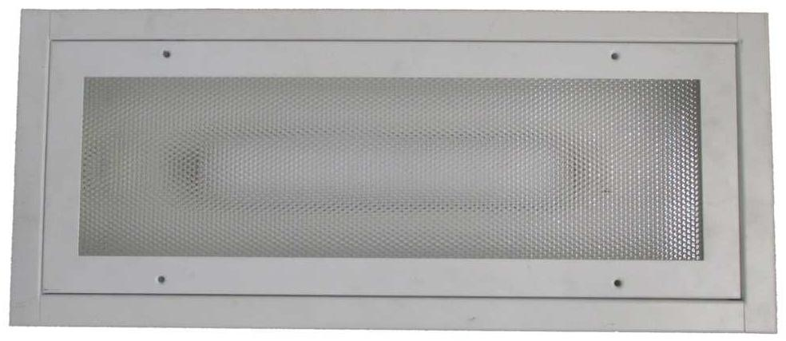

LSM, LED lamp for engine rooms

Designed to replace the lamps that use fluorescent tubes. Elegant metal frame, white, suitable for lighting the engine rooms on medium and large vessels. Flush mounting, suitable for lowered ceiling or ceilings equipped with slats. Bright lighting and uniform wide-ranging, with a neutral white light. They resist humidity and vibration. Prepared for double lighting circuit, total and partial. The low voltage power supply allows the use in emergency circuits.

Technical specifications Dimensions

- Painted metal Case, RAL 9003 white

- Map filter

- Low power consumption: 2 x 8 W (2 x 16 W double density)
• Neutral white light (5000 °K) • Emission angle: 120°
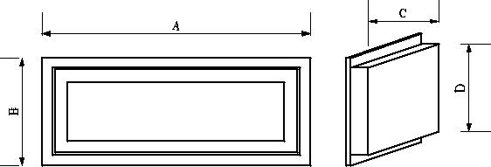
• Power Supply: 24 Vcc

• Luminous intensity: 400 Lux a 1m
• Protection class of 2 internal light tube(Ø 14 mm) : IP52
• Suitable for double illumination circuit (completed or partial)
- Protected against power surges

- Recessed mount

- Dimensions: 620(A) x 260(B) x 570(C) x 210(D) x 45mm(E)

- Work life: 30.000 hours at 25°C

Application
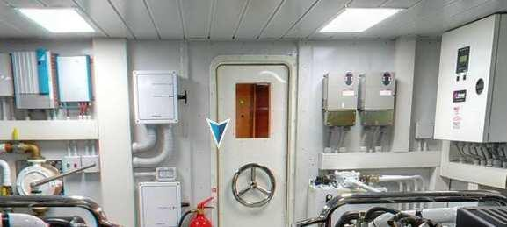

Models | Description
LSM62GW50 | LED lamp, | power supply 24 Vdc, white case, neutral white light (16W)
LSM62GW50DD | LED lamp, | power supply 24 Vdc, white case, neutral white light (32W)

Binding Union srl – via Cuorgnè, 21 – 10156 Torino – Italy – tel. +39.011.2625414 – Fax +39.011.2625428 –www.binding.it – 20

LAMPS
LDL - LED lamps for reading and chartwork
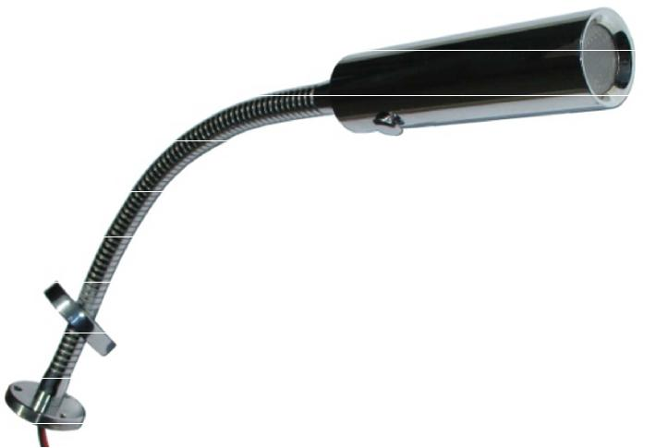

LDL213, LED lamps for reading and chartwork, for interiors

LED lamps in chromed brass. Strong and elegant, suitable for any environment. Intense and uniform lighting. Suitable as reading light and chartwork, warm white light, or red light.

Technical specifications Dimensions

- LED luminous source
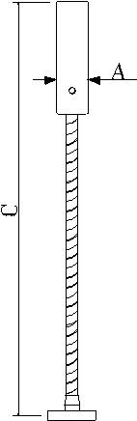
• Warm white light (3200°K, typ.), or red • Emission angle 30°
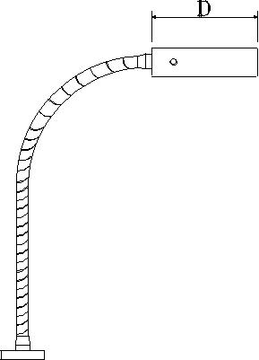
• Power consumption: 3 W • Brass case

• Finish: bright chromed • Protection class: IP44

• Fastening: with screws, not seeable • Power Supply: 12…30 Vdc
• Luminous intensity: 120 lux a 1 m (white light)

• Protected against power surges and polarity inversion • Work life: 30.000 hours @ 25°C
- Dimensions: 26 (A) x 40 (B) x 350 (C) x 96mm (D)

Models | Description
LDL213KW30 | Reading lamp, warm white light, bright chromo finishing, 12…30 Vdc, On-Off
LDL213KR00 | Reading lamp, warm red light, bright chromo finishing, 12…30 Vdc, On-Off
 | Application

Binding Union srl – via Cuorgnè, 21 – 10156 Torino – Italy – tel. +39.011.2625414 – Fax +39.011.2625428 –www.binding.it – 21

LAMPS
DIMMERS - Luminosity changers

ACD001/ACD020 | ACD003
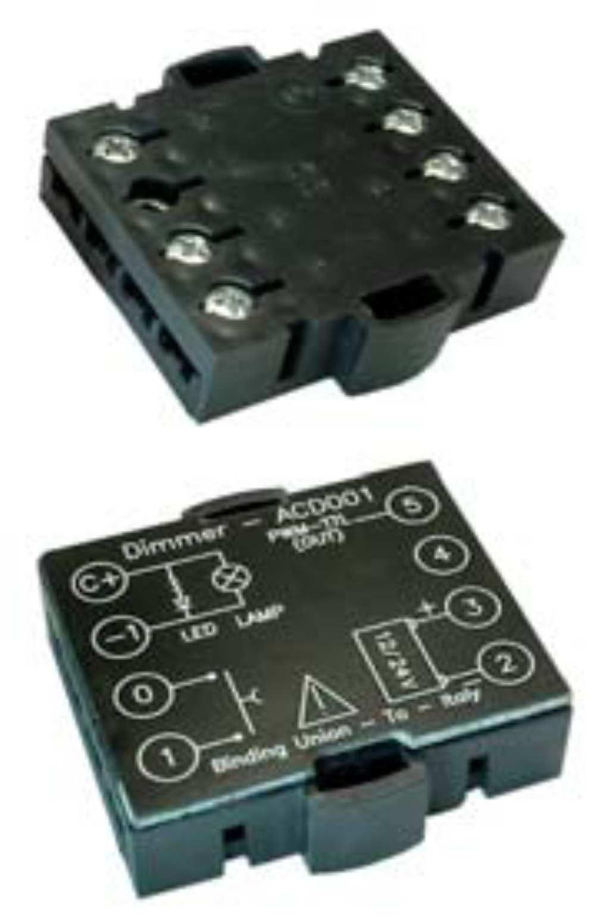
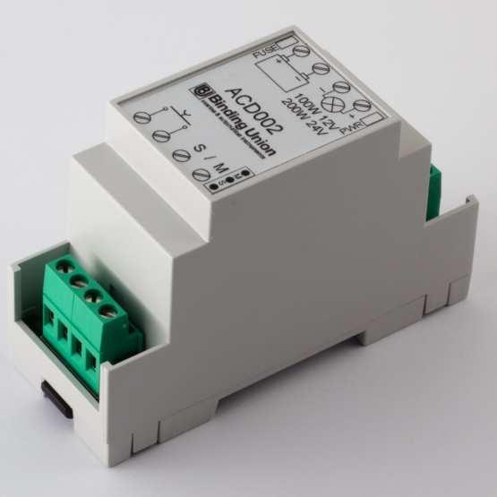

DIMMER, luminosity changer for lamps, LED or filament

Electronic dimmer for controlling incandescent or LED-based lamps, resistive or with a PWM-TTL input. Its compact size allows it to be an ideal fit for thin spaces between walls, ceilings, etc. Driven by buttons of any brand (type SPST momentary), it can regulate the light intensity from any of the switching points of the electrical circuit. Extremely easy operation: breifly pressing the command button switches the light on/off. Keeping the button pressed changes (increases/decreases) the intensity of the light. The present light intensity is kept in memory and restored the next time the lamp is switched on.

Technical specifications

ACD001 ACD003 ACD020

• Fine control of voltage from 0 to 100% • Fine control of voltage from: 2…100%

• For filament or LED lamps, resistive or • For filament or LED lamps, resistive or

electronic PWM-TTL electronic PWM-TTL

• Power output 25 W (12 V), 50 W (24 V) • Power output 100W (12V), 200W (24V)

• Power Supply 12/24 Vdc • Configurable as Master / Slave

• Low auto consumption 20 mAcc max • Power Supply 12/24 Vdc

• Operating temperature: 0...50°C • Low auto consumption 20 mAcc max

• Plastic case • Protection fuses (replaceable)

• Dimensions: 42 x 41 x 12mm • Plastic case

• DIN rail 35mm mounting

• Dimensions: 90 x 35 x 58mm

Electronic flasher for filament or LED lamps. It allows the lighting intermittence where it is connected with adjustable intervals.

- Flashing cycle: adjustable from 0,2 to 5 sec.

- Power output: 15/30 W

- Power Supply: 12/24 Vdc

- Consumption: 20mA, max

- Plastic case

- Dimensions: 42 x 41 x 12mm

Models | Description
ACD001 | Electronic luminosity changer, for charging up to 25W at 12 Vdc (50W at 24 Vdc)
ACD003 | Electronic luminosity changer, for charging up to 100W at 12 Vdc (200W at 24 Vdc)
ACD020 | Adjustable intermittence for LED lamps

Binding Union srl – via Cuorgnè, 21 – 10156 Torino – Italy – tel. +39.011.2625414 – Fax +39.011.2625428 –www.binding.it – 22

LAMPS
GRILLO - Navigation lights controller

Application
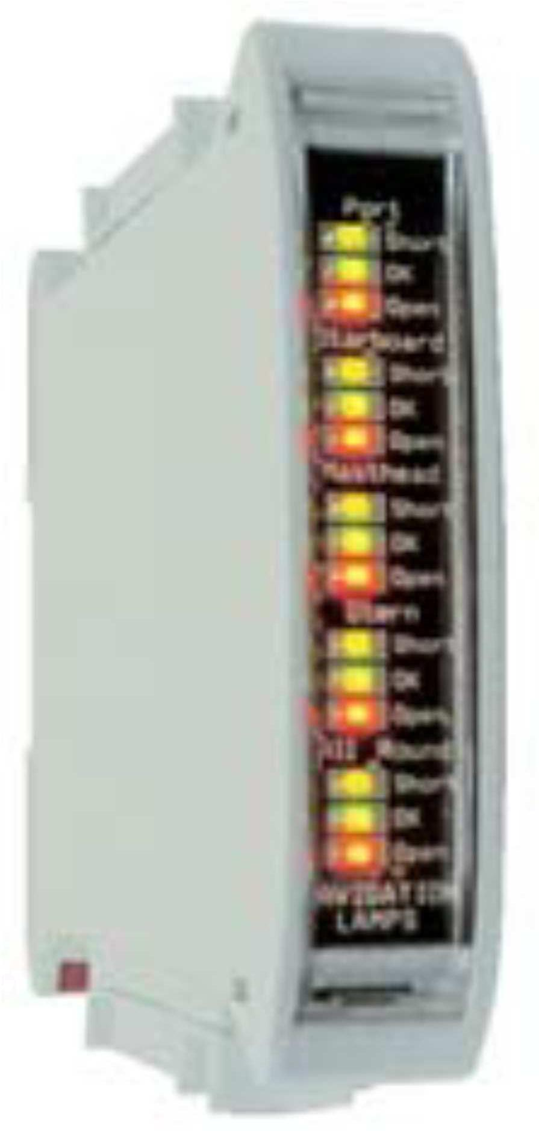

GRILLO, controls the effective navigation lights functioning condition

It directs and monitors constantly the yacht navigation lights. It supports both traditional filament lights and the more recent LED based lights. Each module can monitor up to five lamps. The operating state of the lamps is signaled clearly by leds on its front panel and it is available as a logic output signal, which can be acquired remotely (for instance by a PLC).

The equipment is able to detect the following states:

- In order (lamp is on, green LED)
- Short circuit (lamp is off, yellow LED)

- Open circuit (lamp is off, red LED)

Technical specifications Dimensions

- Increase the safety on board

- Allows the lights working condition verification in clear and quick way.

- For LED and filament lights

- Suitable for charges from 1...25 W at 12 V (1...50 W at 24 V)

- Maximum current for channel: 2 Adc

- Five channels (lights) per module

- Independent alarm output for each channel

- Power Supply: powered by the lamps line

- Compact dimensions and DIN rail mounting (35 mm)
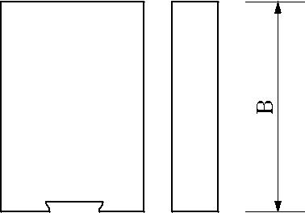
• Electric connections: on screw
• Dimensions: 100 (A) x 22,5 (C) x 120 mm (B)

- Working temperature: 0…60°C

- Weight: 150 g

Models Description

SGR15 Navigation light monitoring, with 5 channels

Binding Union srl – via Cuorgnè, 21 – 10156 Torino – Italy – tel. +39.011.2625414 – Fax +39.011.2625428 –www.binding.it – 23

INDICATORS
PICO - Digital panel meters 3 digit
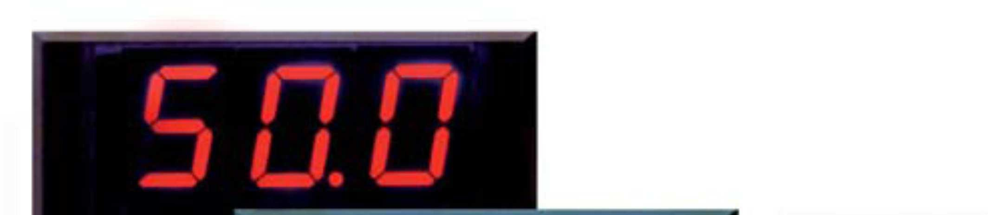

Application
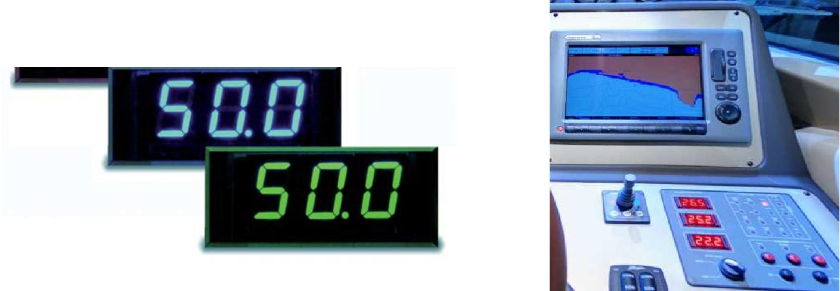

PICO, 3 digits digital signals, with red, green or blue displays

The PICO line is made of a range of digital indicators with a tree-digit display, available in red, green or blue. They provide reliable and accurate measurements. Conceived to be installed on control panels for boats and operating machines, they feature rapid mounting and optimal proportion between display area and overall size.

Technical specifications

- Reading point: 999 digit

- Visualization: 3 digit, red LEDs from 13mm (green or blue on request)

- Input in tension, current, temperature, level and pressure

- Polarity: automatic, only sign minus (-) with LED

- Decimal point: programmable

- Overrange indication: with LED

- Power Supply: 10...30 Vdc / Vac

- Connections: on screw

- Dimensions: 24 (L) x 55 (H) x 53mm (P)

Models | Function | Notes | Accuracy
1510-K | Voltmeter -999...+999mVdc | Suitable also for current measures via shunt | 0,5%
 |  | (100A/100mV) with insulated Power Supply
1513-T | Voltmeter 0...100 Vdc | Direct measure | 0,5%
1524-T | Voltmeter 0...250 Vac (completed of TV AV0223) | With TV | 1%
1535-K | Ammeter for SHUNT 60mV | With Shunt from 10/15/25/50/60 or multiplies | 0,5%
1545-T | Ammeter for TA / 5A | With TA from 50/100/150/250 | 1%
1569-T | Thermometer 0...99.9°C | To use only with AV0361probe | 0,5
1580-T | Process signals 0...10V - 0/4...20mA | Configurable to 0 and FS | 0,5
1588-K | Level/pressure signal for probes 0/10...180Ω | Configurable to 0 and FS | 1%
1589-K | Level/pressure signal for probes 240...33Ω | Configurable to 0 and FS | 1%

Options | Description | Options | Description
AV0223 | Transformer (TV) 240 / 24 Vac | T | Power supply 10…30 Vdc, not
 |  |  | insulated (standard)
AV0385 | Transformer 115 /24 Vac | K | Power Supply 10…30 Vdc, insulated
AV0365 | Performed adaptator 36x72mm (DIN | 45D | Green Display
AV0361 | Temperature probe 0…100°C, con 1,5 m of cable | 45F | Blue Display

Binding Union srl – via Cuorgnè, 21 – 10156 Torino – Italy – tel. +39.011.2625414 – Fax +39.011.2625428 –www.binding.it – 24

INDICATORS
FAST - Digital panel meters 3,5 digit
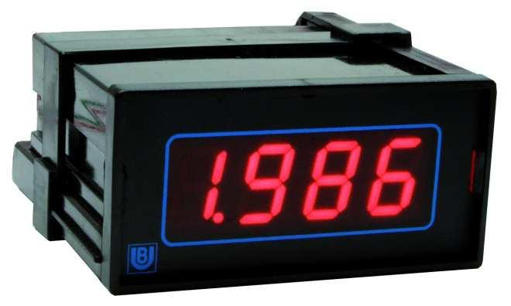

FAST 34, 3,5 digits digital signals, with red displays

Integration, accuracy, ruggedness, functionality and high quality standard are the main features of this line of digital indicators, well known by panel fitters.
Available with one relay alarm threshold.

Technical specifications Application

- Display: 3.5 digit, 14.2 mm (0.56”) red LED’s

- Polarity: automatic, only minus sign (-)

- Decimal point: programmable by front panel

- Reading update: 2.5 per second

- Overrange indication: “1” positive, “-1” negative

- One relay alarm output (SPDT): option (31)

- Power consumption: 4 W

- Conversion technique: dual slope integration

- Connections: screws

- Case: 36x72x81 mm, DIN 43700, black polycarbonate

- Front protection class: IP40
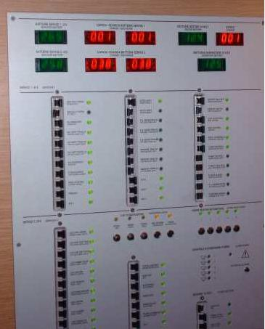
Models | Function | Notes |  |  |  | Accuracy
3402 | Process signals 4…20 mAdc | Configurable reading: full scale |  | 0…1999 - Zero +/- | 1000 | 0,3%
3403 | Custom input signal mAdc / Vdc | Configurable reading: full scale |  | 0…1999 - Zero +/- | 1000 | 0,3%
3404 | Process signals 0…20 mAdc | Configurable reading: full scale |  | 0…1999 - Zero +/- | 1000 | 0,3%
3407 | Process signals 0…10 Vdc | Configurable reading: full scale |  | 0…1999 - Zero +/- | 1000 | 0,3%
3410 | DC Voltmeter -1999… +1999 mV |  | --- |  |  | 0,2%
3411 | DC Voltmeter -199.9… +199.9 mV | Direct measure or via shunt (type 100 A / 100 mV) |  |  |  | 0,2%
3412 | DC Voltmeter -19.99… +19.99 V |  | --- |  |  | 0,2%
3413 | DC Voltmeter -199.9… +199.9 V |  | --- |  |  | 0,2%
3414 | DC Voltmeter -500… +500 V |  | --- |  |  | 0,2%
3422 | AC Voltmeter 0…19.99 V |  | --- |  |  | 0,5%
3423 | AC Voltmeter 0…199.9 V |  | --- |  |  | 0,5%
3424 | Voltmeter for mains line voltage 0…500 Vac |  | --- |  |  | 0,5%
3433 | DC Ammeter -199.9…+199.9 mA |  | --- |  |  | 0,3%
3434 | DC Ammeter -1.999…+1.999 A |  | --- |  |  | 0,3%
3435 | DC Ammeter via shunt 0…60 mVdc | To be coupLED with s hunt of ratio 5-6-10-15-20-25 A and |  |  |  | 0,3%
 |  | multiples
3445 | AC Ammeter 0…5 Aac direct or via C.T. | To be coupLED with CT’s of ratio 5-6-10-15-20-25 A and |  |  |  | 0,5%
 |  | multiples
3466 | Pt100 Thermometer -100,0…+199,9 °C | Temperature meas ure via 3-wire PT100 sensors |  |  |  | 0,5%
3467 | Pt100 Thermometer -100…+650 °C | Temperature measure via 3-wire PT100 sensors |  |  |  | 0,5%
3485 | Frequency meter / tachometer | Measures mains line frequency or rpm’s via pick-ups, |  |  |  | 0,3%
 |  | proximity sensors, optical and NPN/PNP sensors.
 |  | Can power the sensors (5 Vdc)
Options | Description | Options | Description
A | Power supply 230 Vac, 50/60 Hz (default) | H | Power supply +10...40 Vdc, isolated
B | Power supply 110Vac ±10% - 50/60Hz | 10 | Custom configuration/setup
C | Power supply 24Vac ±10% - 50/60Hz | 31 | One relay alarm output (SPDT):

Binding Union srl – via Cuorgnè, 21 – 10156 Torino – Italy – tel. +39.011.2625414 – Fax +39.011.2625428 –www.binding.it – 25

INDICATORS
METER - Digital panel meters 3,5 digit
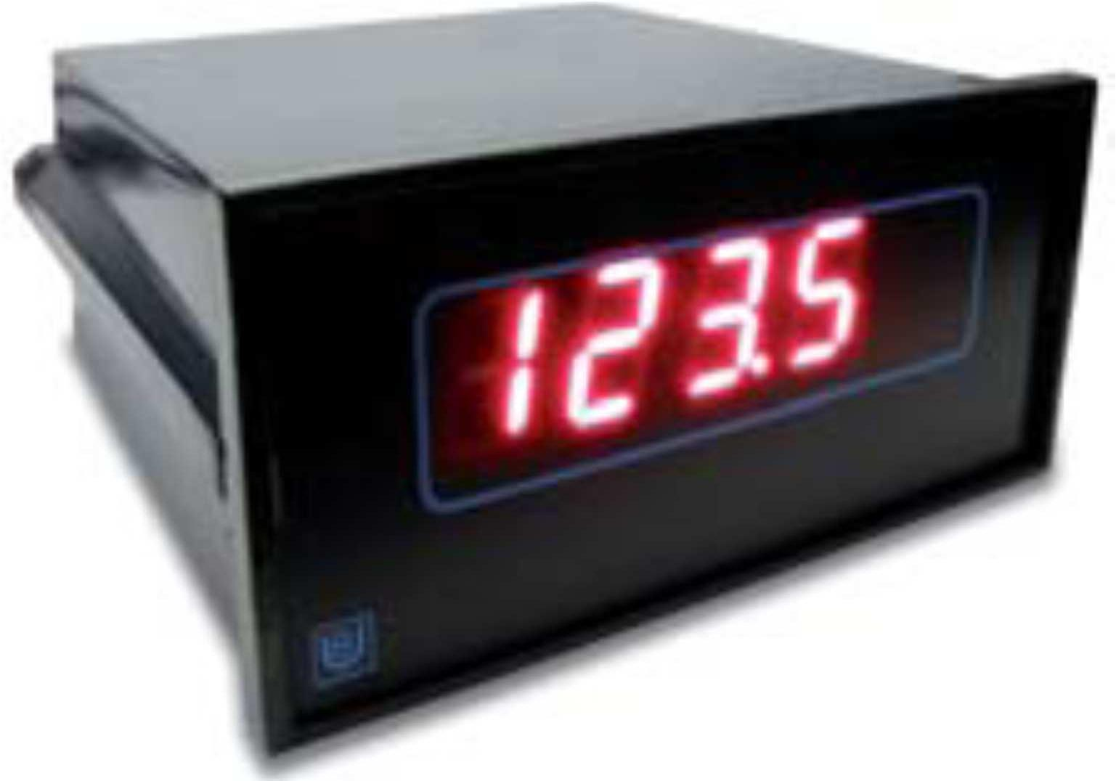

METER - Digital panel meters 3,5 digit

Integration, accuracy, ruggedness, functionality and high quality standards are the main features of this line of digital indicators, well known by panel fitters. Wide range of options and possible configurations (some of which can be done in the fiel d).

Technical specifications Application

- Display: 3.5 digit, 14.2 mm (0.56”) red LED’s

- Polarity: automatic, only minus sign (-)

- Decimal point: programmable by front panel

- Reading update: 2.5 per second

- Overrange indication: “1” positive, “-1” negative

- One or two relay alarm outputs (optional)

- Power consumption: 4 VA

- Connections: screws

- Case: 48x96x112 mm, DIN 43700, black polycarbonate

- Front protection class: IP40

- Weight: 350 g (max)
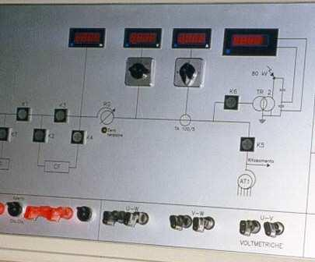
Models | Function |  |  | Notes |  | Accuracy
4403 | Custom input signal mAdc / Vdc |  |  | Configurable reading: full scale +/- 1999 Zero +/- 1999 |  | 0,1%
4480 | Standard Process signals |  |  | 0÷5V,1÷5V,0÷10V,0÷20mA,4÷20mA, Configurable reading |  | 0,1%
4410 | DC Voltmeter -1999… +1999 mV |  |  |  |  | 0,1%
4411 | DC Voltmeter -199.9… +199.9 mV |  |  |  |  | 0,1%
4412 | DC Voltmeter -19.99… +19.99 V |  |  |  |  | 0,1%
4413 | DC Voltmeter -199.9… +199.9 V |  |  |  |  | 0,1%
4414 | DC Voltmeter -500… +500 V |  |  |  |  | 0,1%
4421 | Ac Voltmeter |  | 0…1,999 V | 4426, AC Trms Voltmeter, 0…1,999 V |  | 0,2%
4422 | Ac Voltmeter |  | 0…19,99 V | 4427, AC Trms Voltmeter, 0…19,99 V |  | 0,2%
4423 | Ac Voltmeter |  | 0…199,9 V | 4428, AC Trms Voltmeter, 0…199,9 V |  | 0,2%
4424 | Ac Voltmeter |  | 0…500 V | 4429, AC Trms Voltmeter, 0…500 V |  | 0,2%
4433 | DC Ammeter |  | -199,9…+199,9 mA |  |  | 0,2%
4434 | DC Ammeter |  | -1,999…+1,999 A |  |  | 0,2%
4435 | DC Ammeter via shunt 0…60 mVdc |  |  | SHUNT ratio 4,5,6,8,10,15,20,25-and multiples |  | 0,2%
4443 | AC Ammeter |  | 0…199,9 mA | 4447, AC Trms Ammeter |  | 0,5%
4444 | AC Ammeter |  | 0…1,999 A | 4448, AC Trms Ammeter |  | 0,5%
4445 | AC Ammeter 0…5 A or via C.T |  |  | 4449, AC Trms Ammeter (C.T ratio 5,6,10,15,20,25,40,80-and multiples) |  | 0,5%
4468 | Thermometer via 3-wire PT100 sensors |  |  | 3 scale -100,0÷ +199,9°C / -100÷ +650°C / -328÷ +1562°F |  | 0,5%
4470 | Ohmmeter |  |  | 4 scale – 0…199,9 Ω / 0…1,999 k Ω / 0…19,99 k Ω / 0…199,9 k Ω |  | 0,2%
4482 | Signals from potentiometer |  |  | nominal value in range 0.5...50 kΩ |  | 0,1%
4484 | Signals from load-cells |  |  | value in range 0.5…3.5 mV/V - Cell power supply 10 V ±4% 35 mA |  | 0,1%
4485 | Frequency meter / tachometer |  |  | Measures mains line frequency or rpm’s via pick-ups, proximity sensors, |  | 0,2%
 |  |  |  | optical and NPN/PNP sensors. It can power 5 V sensors (15 V optional)
Options |  | Description |  | Options | Description
K |  | Power supply 10...30 Vdc / Vac |  | 21/22/23 | 1 or 2 relay alarm output (23 = external configuration)
S |  | Power supply 90...270 Vac (default) |  | 25/26/27 | Analog output 0…1mV / 0…10V / 4…20mA
10 |  | Custom configuration/setup |  | 48 | Dummy zero display
 |  |  |  | 82 | 15 Vdc 30 mA auxiliary power supply for sensor (only 4485 mod.)

Binding Union srl – via Cuorgnè, 21 – 10156 Torino – Italy – tel. +39.011.2625414 – Fax +39.011.2625428 –www.binding.it – 26

