LAMPS
ATEX-EX – Led lamp for zone 2, 21, 22
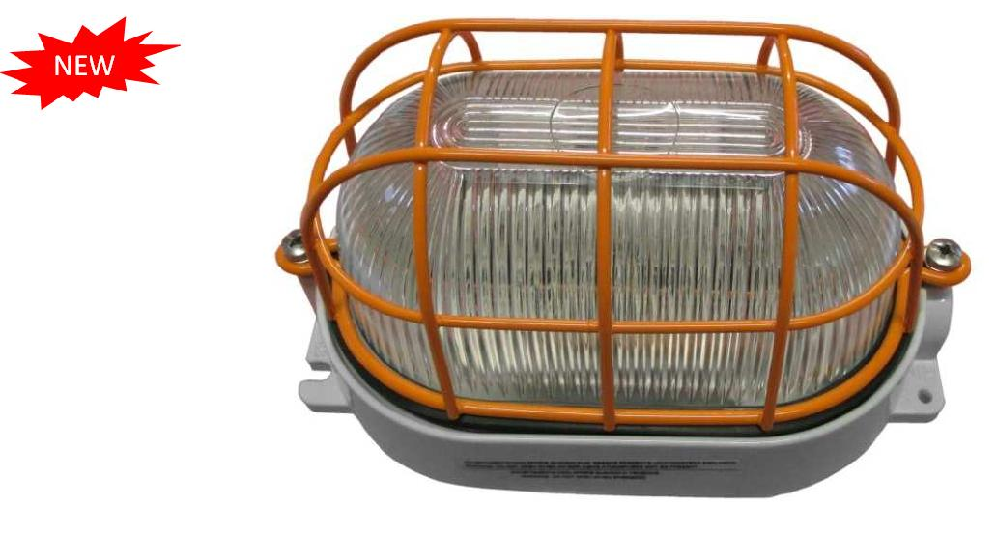

ATEX-EX – Led lamp suitable for zone 2 (GAS) and 21 -22 (DUST)

Waterproof led lamp in aluminium alloy EN1076 AC46001DF suitable for applications in risk of explosion areas as defined in ATEX Directive 94/9/EC. The body of the lighting fixture is treated with ecological anti-corrosion passivation with fluoro-zirconium and finished with hot polymerized scratch-resistant non-toxic polyester painting. The body colour is RAL 7035 light grey. The diffuser is in prismatic tempered glass. The protection cage is RAL 2011 deep orange and is attached to the body by means of stainless steel screws, the sealing is guaranteed by a gasket in non-ageing elastomer. Predisposed for entry through an M20 cable gland.

Complete with internal and external ground screw. Suitable for use in engine rooms

Technical specifications Dimensions

- Body material: aluminium alloy
• Diffuser material: prismatic tempered glass • Back box color: RAL 7035 light grey
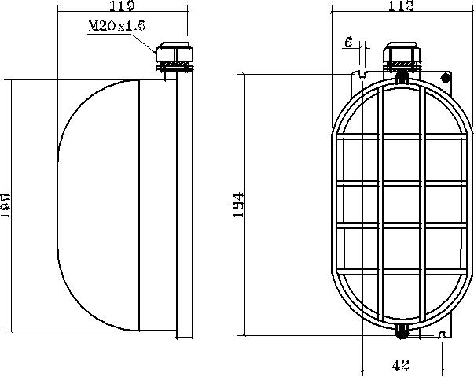
• Protection cage color: RAL 2011 deep orange

- Emission angle: 120°

- Neutral white light

- DC power supply: 10…30 Vcc
• Protection rating: IP65 • Insulation class: I
- Ambient temperature for use: -20…+40°C
• Cable section max: 2,5mm²

- Light intensity: 450 lux a 1 m
• Protected against power surges • Power consumption: 6 W
• Dimensions: 199 x 112 x 119mm
• Operative life: 30.000 hours at 25°C

CONFORMITY TO STANDARDS |  |  | ATEX EXECUTION
 | ATEX Directive 94/9/CE |  | IIC 3G 2D - IP65
Models | Description
LAX120KW50 | Led lamp, surface frame, ATEX execution, neutral white, 10…30Vcc power supply
LAX201152EX | 2 poles Switches, 16A 250Vac, RAL 9005 (black), ATEX execution, IP66 protection rating
LAX9XXKW50 | Led light bulbs, for watertight lighting fixture (ATEX Palazzoli), neutral white, 10…30Vcc p.supply
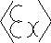

Binding Union srl – via Cuorgnè, 21 – 10156 Torino – Italy – tel. +39.011.2625414 – Fax +39.011.2625428 –www.binding.it – 7

LAMPS
LUXBOMA - LED boom lamps, with courtesy light
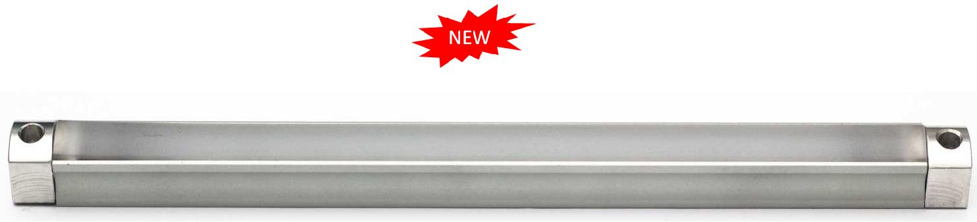

LUXBOMA, LED boom lamps with courtesy light

LED lamps for the cockpit lighting. Elegant finishing, reduced dimensions, long duration and low power consumption.

Can be placed in the boom inferior groove (for ex. Selden™ and Sparcraft™). White main light and red courtesy one
Suitable also for assembly under crosstrees, rollbar and awnings on in motor vains

Technical specifications Application
- Case in anodized aluminum

- Emission angle 60°

- Cold white main light (5800°K)

- Red courtesy light

- Sea cable of 40 cm

- Power Supply: 10…30 Vdc

- High protection class IP66

- Luminous intensity: 450 lux at 1 m

- Protected against polarity inversion

- Protected against power surges

- Low power consumption (6 W), long duration

- Dimensions: 325 (Length) x 18 (A) x 18 mm (B)

- Work life: 30.000 hours @ 25°C
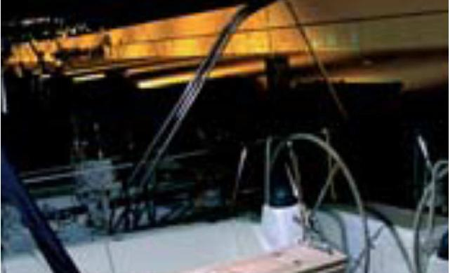

Dimensions
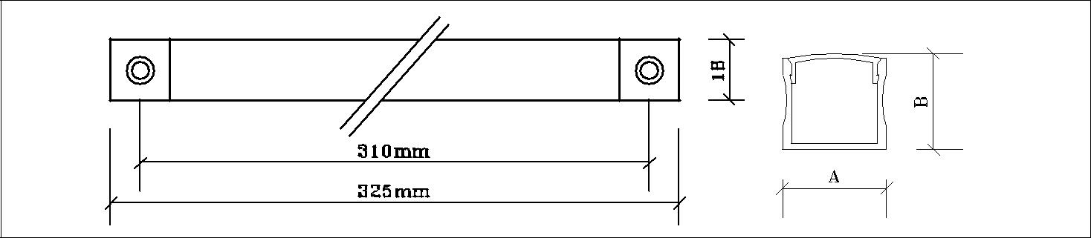

Models Descriptions

LXB830KWR Surface mount lamp, white light, red courtesy one

AV0478 Mounting plastic clips (set of two)

Binding Union srl – via Cuorgnè, 21 – 10156 Torino – Italy – tel. +39.011.2625414 – Fax +39.011.2625428 –www.binding.it – 8

LAMPS
COURTESY LIGHTS

PERLA, LED courtesy lights for internals and externals

Small and bright lights available in white, blue, red, green and amber. Designed for exterior use, with a single-piece case and fully resined inside, they are completely waterproof. They allow a simple and rapid installation and can be fixed with glue or screwed in and blocked with a nut. Useful for illuminating or marking steps, borders, ladders, bathrooms, cockpit area and other environments.

Technical specifications Application
- Polycarbonate case

- Emission angle 30°

- Models: white, blue, red, green and amber light

- Cable: 20 cm

- Power Supply: 10…30 Vdc

- High protection class IP67

- Luminous intensity: 20 lux 1 LED (1 m)

- No polarity

- Thread: 12 MA x 1,5 mm

- Low power consumption: 0,3 W (12V), 0,6W (24V)

- Dimensions: Ø 12 x 24 mm

- Work life: 30.000 hours @ 25°C

Models | Description | Models | Description
LPE112KW | White courtesy light | LPE112KA | Amber courtesy light
LPE112KB | Blue courtesy light | AV0411 | Chromed brass frame, Ø 24 x 6mm
LPE112KR | Red courtesy light | AV0414 | Gilded brass frame, Ø 24 x 6mm
LPE112KG | Green courtesy light | AV0454 | Line protection

GEMMA, LED courtesy lights for internals and externals

Compact and bright lamps for exteriors. Available with light of colour white, blue, red, green or amber. With a single-piece case and fully resined inside, they are completely waterproof. They allow a simple and rapid installation and can be fixed anywhere with glue or screwed in and blocked with the nut. Useful for illuminating or marking steps, borders, ladders, cockpit area, bathrooms and other environments. They can be powered with any voltage between 10 and 30 Vdc..

Technical specifications Application

- Polycarbonate case

- Emission angle 30°

- Models: white, blue, red, green and amber light

- Cable: 20 cm

- Power Supply: 10…30 Vdc

- High protection class IP67

- Luminous intensity: 20 lux 1 LED (1 m)

- No polarity

- Thread: 12 MA x 1,5 mm

- Low power consumption: 0,3 W (12V), 0,6W (24V)

- Dimensions: Ø 18 x Ø 12 x 24 mm

- Work life: 30.000 hours @ 25°C
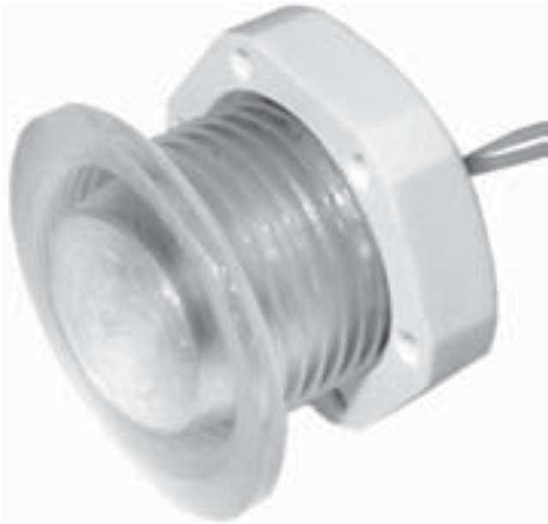
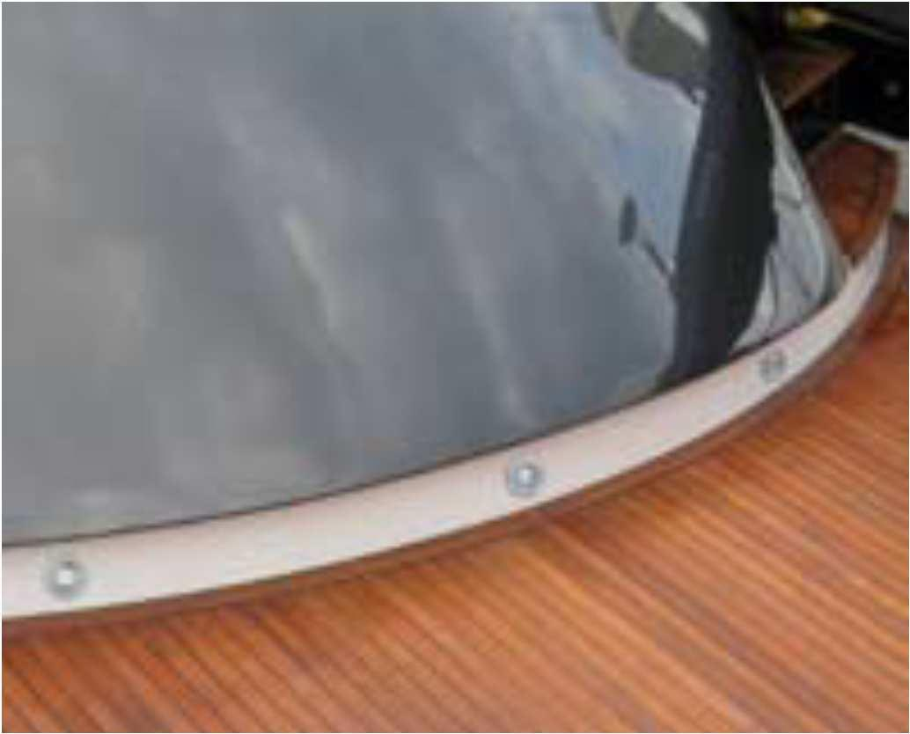
Models | Description | Models | Description
LGE118KW | White courtesy light | LGE118KG | Green courtesy light
LGE118KB | Blue courtesy light | LGE118KA | Amber courtesy light
LGE118KR | Red courtesy light | AV0391 | Stainless frame, dim. Ø 32 x 4mm

Binding Union srl – via Cuorgnè, 21 – 10156 Torino – Italy – tel. +39.011.2625414 – Fax +39.011.2625428 –www.binding.it – 9

LAMPS
GIADA - LED lamp for interiors
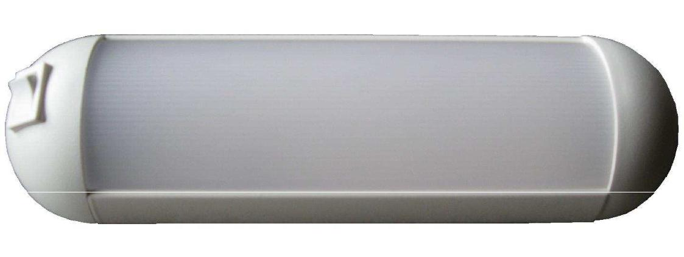

GIADA, LED lamps for interiors

New-concept minimal design, based on LED technology. Light emission is wide and uniform. Designed to be used on work panels, engine rooms, lifts, kitchens and wardrobes. Models available, with or without onboard power switch. Their low power consumption makes them useful for emergency scenarios, powered by a battery.

Technical specifications Application
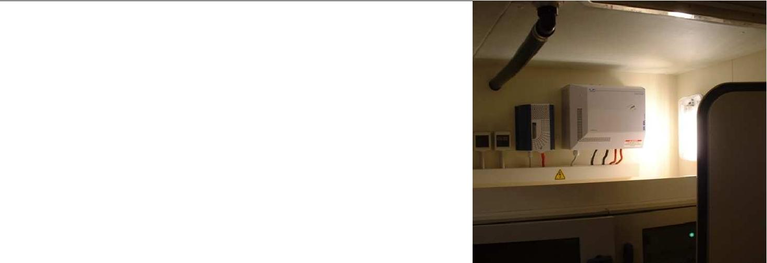
- High brightness, bright light

- Aluminum and plastic case

- Neutral white light (4500 °K)

- Emission angle: 120°

- Opaline filter

- Power Supply: 10…30 Vdc

- Luminous intensity: 80 lux 1 m

- No polarity

- Protection class: IP42

- Protected against power surges

- Low power consumption: 6 W

- Work life: 30.000 hours @ 25°C

- Dimensions: 240 (A) x 70 (C) x 35mm (B)

Dimensions
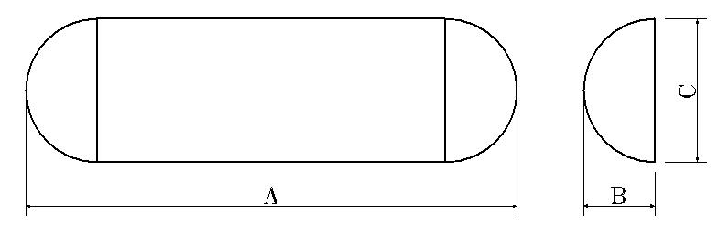

Models Description

LGD114KW LED lamp for internals, without switch, opaline front filter.

LGD214KW LED lamp for internals, with switch, opaline front filter

Binding Union srl – via Cuorgnè, 21 – 10156 Torino – Italy – tel. +39.011.2625414 – Fax +39.011.2625428 –www.binding.it – 10

LAMPS
LED MODULAR LAMPS
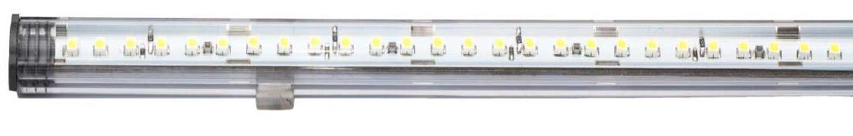

PRISMA
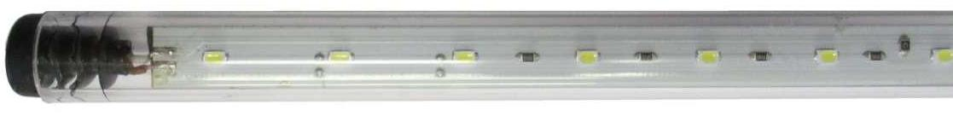

SIBILLA

PRISMA/SIBILLA, LED modular lamps for interiors and exteriors

Suitable to light ambients, as kitchen, baths, cabinets, motor vains, lockers, cockpits and awnings. Suitable where it is useful to have strong lamps, of minimum size, long duration and low consumption

Technical specifications |  | PRISMA | SIBILLA
• | 4 standard sizes
• Neutral white light: 5000 °K
• Emission angle 90° Prisma
• Emission angle 120° Sibilla
• | Power supply: 12 o 24 Vdc |  | AV0425
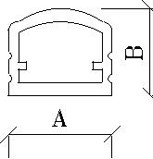
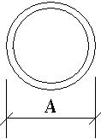
- Prisma light intensity: 310 lux 1 m (530 lux double density)
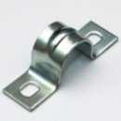
• | Sibilla light intensity: 280 lux 1 m (480 lux double density) | AV0428
• | IP54 plastic case
• | Protected against power surges | AV0426
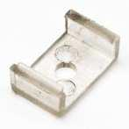
- Prisma dimensions: 12,5 (A) x 10,5mm (B) x 220…99 0 mm

- Sibilla dimensions: Ø 14mm x 220…990 mm

- Set of two metal or plastic clasps for mounting
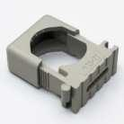
Models | Description | Length | Consumption | N° led’s
LPI122FW40 | LED lamp, 12 Vdc | 220mm | 3,2 W | 12
LPI151FW40 | LED lamp, 12 Vdc | 510mm | 8 W | 30
LPI171FW40 | LED lamp, 12 Vdc | 710mm | 11,2 W | 42
LPI199FW40 | LED lamp, 12 Vdc | 990mm | 16 W | 60
LPI227FW40 | LED lamp, 12 Vdc, double density | 270mm | 8 W | 30
LPI251FW40 | LED lamp, 12 Vdc, double density | 510mm | 16 W | 60
LPI277FW40 | LED lamp, 12 Vdc, double density | 770mm | 24 W | 90
LPI299FW40 | LED lamp, 12 Vdc double density | 990mm | 32 W | 120
LSI122FW40 | LED lamp, 12 Vdc | 220mm | 3,2 W | 12
LSI151FW40 | LED lamp, 12 Vdc | 510mm | 8 W | 30
LSI171FW40 | LED lamp, 12 Vdc | 710mm | 11,2 W | 42
LSI199FW40 | LED lamp, 12 Vdc | 990mm | 16 W | 60
LSI227FW40 | LED lamp, 12 Vdc, double density | 270mm | 8 W | 30
LSI251FW40 | LED lamp, 12 Vdc, double density | 510mm | 16 W | 60
LSI277FW40 | LED lamp, 12 Vdc, double density | 770mm | 24 W | 90
LSI299FW40 | LED lamp, 12 Vdc, double density | 990mm | 32 W | 120

Models | Options | Models | Accessories
G | 24 Vdc power supply | AV0425 | Set of two metal clasps for mounting
30 | Warm white light 3000°K | AV0426 | Set of two plastic clasps for mounting
 |  | AV0428 | Set of two plastic clasps for mounting

Binding Union srl – via Cuorgnè, 21 – 10156 Torino – Italy – tel. +39.011.2625414 – Fax +39.011.2625428 –www.binding.it – 11

LAMPS
SPOT - LED light bulbs

SPOT 28, LED lamps, diameter 28 mm, for G4 and GU 5.3 sockets

High efficiency LED lamps. They replace the halogen lamps from 15 W and offer a consumption of only 2,2 W with an operating life 10 times superior. They emit a pleasant warm white light (very similar to the halogen one) that is given out in uniform way in the environment thanks to the wide and uniform emission angle.

The available model satisfies different needs of Power Supply and connection.

Technical specifications Dimensions

- Replace the halogen bulbs from 15W

- Bulb diameter: 28 mm

- G4 and GU5.3 sockets (central, changeable in
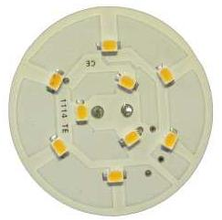
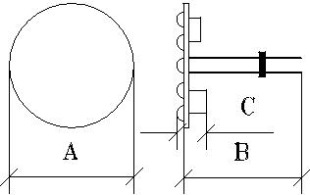
lateral surface)

• Warm white light (3000 °K), CRI80 • Emission angle 120°
• Power Supply: 10…30 Vdc

- Luminous intensity: 40 lux at 1 m (11 lux-2m)

- No polarity

- Protected against power surges

- Low power consumption 2,2 W

- Dimensions: 28 (A) x 30 (B) x 8 mm (C)

- Work life: 30.000 hours @ 25°C

Models | Description | Models | Accessories
LSP28CKW30 | LED lamp, socket G4/GU5.3 central, 10÷30Vdc | AV0454 | Line protection

SPOT 35, LED lamps, diameter 35mm, for G4 and GU 5.3 sockets, with dimmer

High efficiency LED lamps. They replace the halogen lamps from 20 W and offer a consumption of only 3 W. They emit a pleasant warm white light (very similar to the halogen one) that is given out in uniform way in the environment thanks to the wide and uniform emission angle.
The available model satisfies different needs of Power Supply and connection.

Technical specifications Dimensions

- Replace the halogen bulbs from 20W

- Bulb diameter: 35 mm
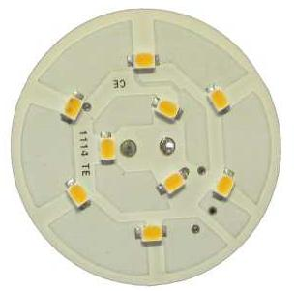
• G4 e GU5.3 sockets (central, changeable in lateral surface)
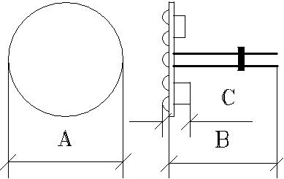
• Warm white light (3000 °K), CRI80 • Emission angle 120°
• Power Supply: 10…30 Vdc

• Luminous intensity: 55 lux at 1 m (15 lux-2 m)

- Protected against power surges

- Low power consumption 3 W

- Dimensions: 35 (A) x 30 (B) x 8 mm (C)

- Work life: 30.000 hours @ 25°C

Models | Description | Models | Accessories
LSP35CKW30 | LED lamp, sockets G4/GU5.3 central | ACD003 | Dimmer, 100 W (12 Vdc)
LSP35CKW30D | LED lamp, sockets G4/GU5.3 central, dimmable | AV0454 | Line protection

Binding Union srl – via Cuorgnè, 21 – 10156 Torino – Italy – tel. +39.011.2625414 – Fax +39.011.2625428 –www.binding.it – 12

LAMPS
SPOT - LED light bulbs

SPOT 50, LED lamps, diameter 50 mm, for internal and external use

High protection and efficiency LED lamps. They replace the halogen lamps from 20 W and offer a power consumption of only 3 W with an operative life 10 times superior. They emit a pleasant warm white light (very similar to the halogen one) that is given out in uniform way in the environment thanks to the wide and uniform emission angle. Suitable also to be installed in external environments (option S).

Technical specifications Dimensions

 |  | • Diameter 50mm, wires connection
 |  | • Low power consumption: 3 W
 |  | • Warm white light: 3000 °K (neutral 4000°K)
 |  | • | Emission angle 120°
 |  | • Dimmable models (Dimmer ACD003)
 |  | • | Satinized front filter
 |  | • Power Supply: 12 Vdc/ac,10÷30 Vdc
 |  | • Protection class IP40 (IP65 option S)
 |  | • Luminous intensity: 55 Lux-1m (15 at 2m)
 |  | • Protected against power surges
 |  | • Work life: 30.000 hours at 25°C
 |  | • | Dimensions: 50 (A) x 22 (B) x 43mm (C)
 |  | • Recessed hole: Ø 46 (option version “M”)
Models | Description
LSP50FJW30 | LED lamps for internals, 12 Vdc/ac, warm white light (3000°K)
LSP50FKW40 | LED lamps for internals, 10..30 Vdc, neutral white light (4000°K)
LSP50FKW30D | LED | lamps for internals10..30 Vdc,, warm white light (3000°K), dimmerable
LSP50FKW40D | LED | lamps for internals, 10..30 Vdc, neutral white light (4000°K), dimmerable
S | Protection cap (IP65), for external use
M | Springs for the recessed insertion (not compatible with the option “S”)
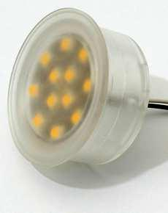
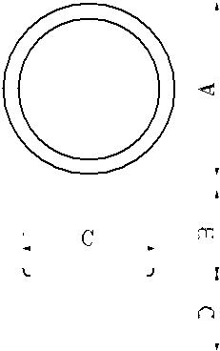

SPOT MR16, LED lamps, diameter 50mm, with GU5.3 socket, for internals

LED lamps with high efficiency, same size of the dichroic 20 W halogen ones, but have a power consumption of only 3W with an operative life 10 times superior. They emit warm white light (similar to the halogen) given out in uniform way in the environment thanks to the wide emission angle.

Technical specifications Dimensions

- Lamps equal to the halogen ones by 20 W
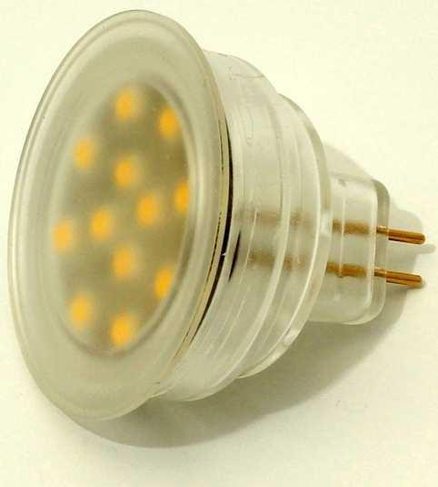
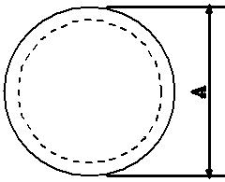
• Diameter: 50 mm, with socket GU5.3 • Warm white light (3000 °K)
• Emission angle 120° • Satinized filter
• Power Supply: 12 Vdc/ac

• Luminous intensity: 55 lux at 1 m (15 lux 2m)
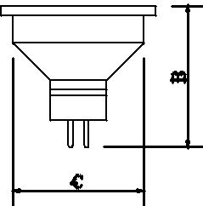
- No polarity
• Protected against power surges

- Low power consumption 3 W
• Dimensions: 50 (A) x 47 (B) x 44mm (C) • Work life: 30.000 hours at 25°C

Models Description

LSPM16JW30 LED lamp, GU5.3 socket, 12 Vdc/ac

Binding Union srl – via Cuorgnè, 21 – 10156 Torino – Italy – tel. +39.011.2625414 – Fax +39.011.2625428 –www.binding.it – 13

LAMPS
ZEN - LED spotlights, recessed mount, for interiors
ZEN 45, LED spotlights, recessed mount, for interiors (transparent filter)

Essential and minimum size, very thin. Suitable for classic and modern environments. Chromed plastic frame. Suitable to light closets, kitchens or as courtesy lights.
The low consumption allows to use them in high autonomy emergency plants.

They offer a simple and quick installation; they can be fastened under pressure or with the nut.

Technical specifications

Transparent filter
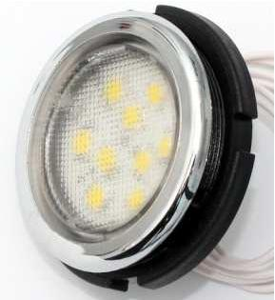

Map filter
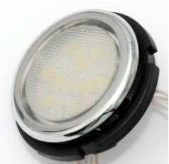
- Equivalent to the halogen ones by 15W

- Low power consumption: 2,2W (9 LED)

- Power Supply: 10…30 Vdc

- Emission angle 120°

- Neutral white light (4000°K)

- Luminous intensity: 33 lux at 1 m (13 lux at 2 m)

- No polarity and protected against power surges

- Recessed mounting: pressure fastening or with the die

- Wires connections from 30cm

- Protection class: front IP66, back IP40

- Dimensions: 45 (A) x 19 (C) x 40,8 mm (B), hole Ø 41,0 mm

- Work life: 30.000 hours at 25°C

Dimensions
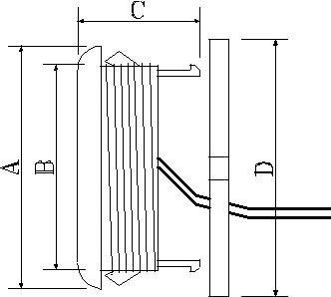

Models | Description
LZE45KW40T | 9 LED spotlight, Ø 45mm, hole Ø 41mm, 2 wires, 10…30 | Vdc, neutral white light, transparent filter
LZE45KW40L | 9 LED spotlight, Ø 45mm, hole Ø 41mm, 2 wires, 10…30 | Vdc, neutral white light, map filter

ZEN 45, LED spotlights, recessed mount, for interiors bicolored

Essential and minimum size, very thin. Chromed plastic frame. Suitable to light throughfare or as courtesy lights, two-colors. They offer a simple and quick installation; they can be fastened under pressure or with the nut.

Technical specifications

• Low consumption: 1 W (9 LED) • Power Supply: 10…30 Vdc
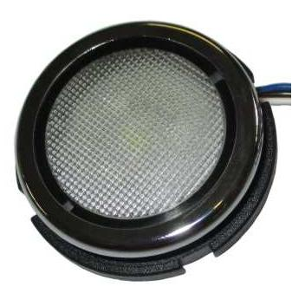
• Emission angle 120° • White and blue light
• Protected against polarity inversion • Protected against power surges
• Recessed mounting: hole Ø 41mm, pressure fastening or with the die • Wires connections from 30cm
• Protection class: front IP66, back IP65

• Dimensions: 45 (A) x 19 (C) x 40,8 mm (B), hole Ø 41,0 mm

Models Description

LZE45KWB LED spotlight, Ø 45mm, 10…30 Vdc,, white light and bl ue courtesy light, map filter

Binding Union srl – via Cuorgnè, 21 – 10156 Torino – Italy – tel. +39.011.2625414 – Fax +39.011.2625428 –www.binding.it – 14

LAMPS
SABA - LED spotlights, recessed mount, stainless

Application
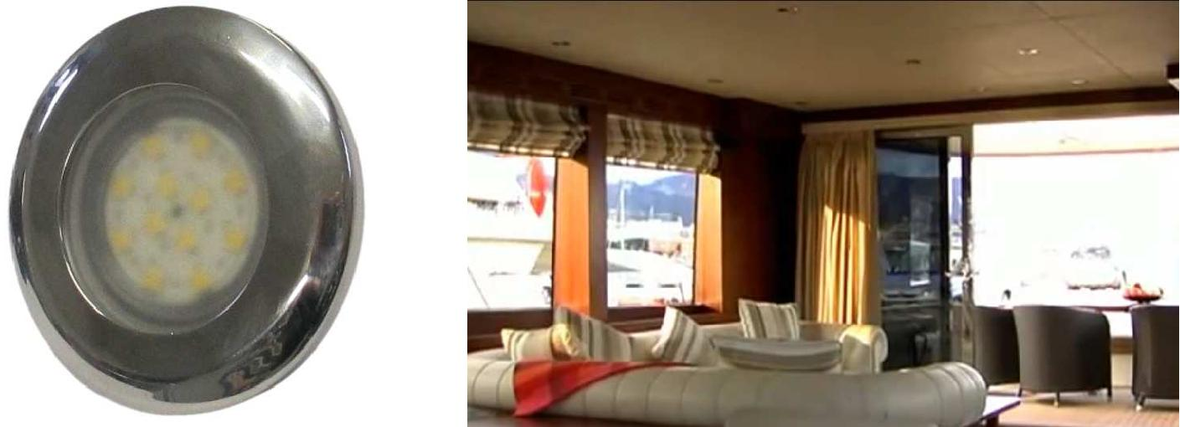

SABA, LED spotlights, recessed mount, s.steel frame, for interiors and exteriors

Elegant stainless steel structure AISI 316. Intense and uniform lighting with a wide emission angle. Suitable for classic and modern environments. Standard gloss finish or satin (option). Suitable to light cabins, kitchens, cockpit, baths, integrated directly in the furniture, motor vain. Their low power consumption allows them to be used in emergency setups.

Technical specifications Dimensions

- Stainless steel AISI 316 case

- Equivalent to halogen spotlights of 20 W
• Emission angle 120°
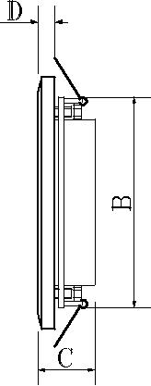
- Matte filter
• Warm white light (3000°K) or Neutral white light (4000°K) • Low power consumption: 3 W
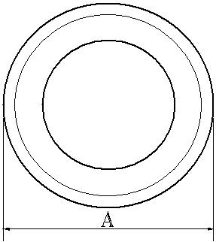
- Power Supply: 12 Vdc/ac
• Power Supply: 10…30 Vdc, also with dimmer (ACD001/ 3)

- Protection class: IP52 front, IP20 back

- Usable also to the external: with S option (IP65)
• Luminous intensity: 55 Lux at 1m (15 Lux at 2m) • Protected against power surges
• Recessed mounting, with spring fastening

- Dimensions: 78 (A) x 62 (B) x 30 (C) x 8mm (D)

- Work life: 30.000 hours at 25°C

Models | Description
LSA80RJW30 | LED spotlight, bright finishing, Power Supply 12 Vdc/Vac, Warm white light
LSA80RKW40 | LED spotlight, bright finishing, Power Supply 10…30 Vdc , Neutral white light
LSA80RKW30D | LED spotlight, bright finishing, Power Supply 10…30 Vdc , Warm white light , with dimmer
LSA80RKW40D | LED spotlight, bright finishing, Power Supply 10…30 Vdc , Neutral white light , with dimmer
B | Satinized finishing
S | Treatment for IP65 external use
ACD001 | Dimmer for loads up to 25 W (12 Vdc) – 50 W (24 Vdc)
ACD003 | Dimmer for loads up to 100 W (12 Vdc) – 200 W (24 Vdc)
AV0454 | Line protection

Binding Union srl – via Cuorgnè, 21 – 10156 Torino – Italy – tel. +39.011.2625414 – Fax +39.011.2625428 –www.binding.it – 15

LAMPS
PUNTO - Recessed LED spotlight for interiors
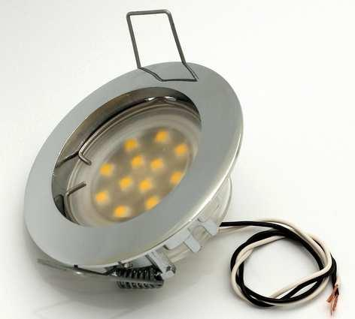

PUNTO, Recessed LED spotlight for interiors

Compact and elegant, they are suitable for classic and modern rooms. Alluminium alloy frame with chromium-plated finish (on request white or golden). They are suitable for lift cars, elevator shafts and engine rooms. The Low power consumption allows to use them in high autonomy emergency plants. They are also available pre-cabled for fast hooking/unhooking..

Technical specifications Dimensions

- Corresponding to 20 W halogen spotlight
• Low power consumption 3 W
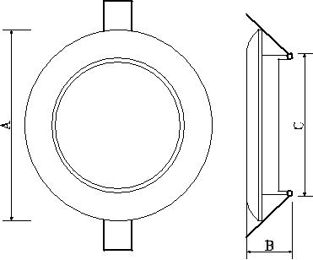
• Two power supply types: 12 Vdc/ac, 10…30 Vdc

- Emission angle 120°

- Warm white light (3000°K) or neutral (4000°K)

- Lighting intensity 55 Lux at 1 m, 15 Lux at 2 m

- Without polarity, Protected against power surges

• Cable with connector for fast hooking/unhooking (P option) • Recessed mount, with spring fastening
- Dimensions LPT75 models: 75 (A) x 65 (C) x 30mm (B)

- Dimensions LPT60 models: 60 (A) x 48 (C) x 30mm (B)

- Protection class IP40 (IP65 with S option)

- Operative life: 30.000 hours at 25°C

Pre-cabled system
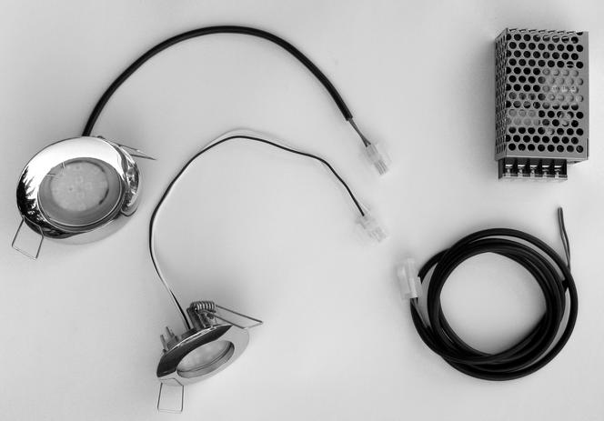

Models | Description | Models | Description
LPT75JW30 | LED spotlight, 12 Vdc/ac, Warm white | P | Connettor on the power supply cable
LPT75KW40 | LED spotlight, 10÷30 Vdc, neutral white | S | Treatment for protection IP65
LPT60KW40T | LED spotlight, 10÷30 Vdc, neutral white | AV0424 | Extension 1200mm
D | Frame golden finishing | AV0454 | Line protection
W | Frame white finishing | AV0438 | Power supply 100-240 Vac / 12 Vdc, 25 W

Binding Union srl – via Cuorgnè, 21 – 10156 Torino – Italy – tel. +39.011.2625414 – Fax +39.011.2625428 –www.binding.it – 16

