INDICATORS
MICRO - Multifunction digital panel meters 4,5 digit
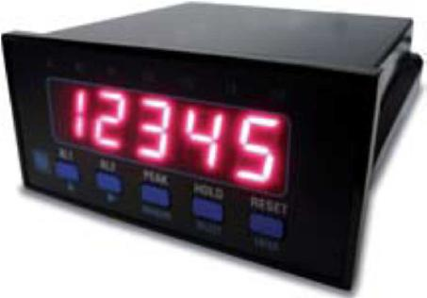

MICRO - Multifunction digital panel meters 4,5 digit

The meters of the MICRO line are microprocessor-based, with 20.000 display steps.

All functions can be programmed from the front panel in a very simple way and, among others, can be displayed peak, hold and tare values. Programmable reading is particularly suited wherever voltage signal must be presented with multiplication or division factors.

Technical specifications

- Display: 4.5 digit, 14.2 mm (0.56”) red LED’s

- Polarity: automatic, only minus sign (-)

- Parameter programming: by the keyboard

- Reading update: 12.5 per second

- Overrange indication: “OFL” positive, “-OFL” nega tive

- Reading update: from 1:1 to 1:100

- Power consumption: 4 VA

- Sensor power supply: 24 Vdc ±4% - 30 mA

- 2 relay alarm outputs 1 A – 250 Vac – 50 VA max

- Programmable hysteresis alarms: 0...999 digits

- Alarm intervention delay: from 0 to 9 s

- Connections: screws

- Case: 48x96x112 mm, DIN 43700, black polycarbonate

- Front protection class: IP40 - Weight: 400 g (max)

Models | Function | Notes | Accuracy
9480 | Process signals 0…5 V, 1…5 V, 0…10 V | Config. reading: full scale +/- 19999 Zero +/- 19999 | ±0,1%
 | 0…20 mA, 4…20 mA
9410 | DC Voltmeter, -1,9999…+1,9999 V | Config. reading: full scale +/- 19999 Zero +/- 19999 | ±0,05%
9412 | DC Voltmeter, -19,999…+19,999 V | Config. reading: full scale +/- 19999 Zero +/- 19999 | ±0,05%
9413 | DC Voltmeter, -199,99…+199,99 V | Config. reading: full scale +/- 19999 Zero +/- 19999 | ±0,05%
9414 | DC Voltmeter, -500,0…+500,0 V | Config. reading: full scale +/- 19999 Zero +/- 19999 | ±0,05%
9421 | AC Voltmeter, 0…1,9999 V | 9426, AC Trms Voltmeter, 0…1,9999 V | 0,2%
9422 | AC Voltmeter, 0…19,999 V | 9427, AC Trms Voltmeter, 0…19,999 V | 0,2%
9423 | AC Voltmeter, 0…199,99 V | 9428, AC Trms Voltmeter, 0…199,99 V | 0,2%
9424 | AC Voltmeter, 0…500,0 V | 9429, AC Trms Voltmeter , 0…500,0 V | 0,2%
9433 | DC Ammeter -199,99…+199,99 mA | Config. reading: full scale +/- 19999 Zero +/- 19999 | 0,2%
9434 | DC Ammeter -1,9999…+1,9999 A | Config. reading: full s cale +/- 19999 Zero +/- 19999 | 0,2%
9435 | DC Ammeter via shunt 0…60 mVdc | SHUNT ratio 4,5,6,8, 10,15,20,25 - and multiples | 0,2%
9443 | AC Ammeter 0…199,99 mA | 9447, AC Trms Ammeter, 0…199,99 mA | 0,5%
9444 | AC Ammeter 0…1,9999 A | 9448, AC Trms Ammeter, 0…1,9999 A | 0,5%
9445 | AC Ammeter 0…5 A or Via CT | 9449, AC Trms Ammeter, 0…5 A or Via CT | 0,5%
9468 | 3-wire PT100 Thermometer | 3 scale,-100,00÷+199,99° C / -100,0÷+650,0°C / -328,0÷+1562,0°F | 0,5%
9470 | 4-wire Ohmmeter | 4 scale, 0÷199,99 Ω / 0÷1,9999 k Ω / 0÷19,999 k Ω / 0÷199,99 k Ω | 0,2%
9482 | Signals from potentiometer | nominal value in range 0.5...50 kΩ | 0,1%
9484 | Signals from load-cells | value in range 0.5…3.5 mV/V - Cell power supply 10 V ±4% 35 mA | 0,1%
9485 | Frequency meter / tachometer | Measures mains line frequency or rpm’s via pick-ups, proximity sensors, | 0,2 %
 |  | optical and NPN/PNP sensors.It can power 5 V sensors (15 V optional)

Options | Description | Options | Description
K | Power supply 10...30 Vdc / Vac | 59/60/61 | Analog output 0…10V, 0/4…20mA, 0…5V, -/+5V
S | Power supply 90...270 Vac (default) | 69 | Optoisolated RS232 output
10 | Custom configuration/setup | 82 | 15 Vdc 30 mA auxiliary power supply for sensor (only 4485 mod.)

Binding Union srl – via Cuorgnè, 21 – 10156 Torino – Italy – tel. +39.011.2625414 – Fax +39.011.2625428 –www.binding.it – 27

INDICATORS
PULSAR - Tachometer, rpm indicator
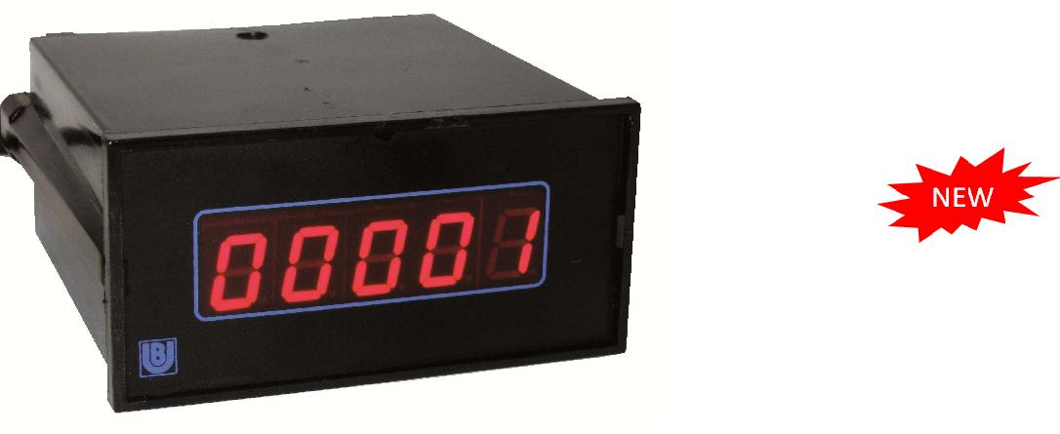

PULSAR, tachometer, rpm indicator

Model PULSAR 9011 is a tachometer conceived for the detection of revolutions per minute (rpm) via a proximity sensor with a single mark on the moving part.
It is ideal for measuring the rpm of engines in the automation and marine sectors.

Technical specifications

- Reading points: 99999

- Display: 5 digits, 13 mm red LED’s

- Accuracy: ±0.1 rpm /min

- Temperature stability: 75 ppm (typ.) 100 ppm (max)

- Reading update: quartz-based, sampled once a sec.
• Power supply: 230Vac (50…60Hz) and 9…28Vdc (A) or 115Vac and 9…28Vdc (option B)

- Connection: screw, max section 2.5 mm²

- Decimal point disabled by terminal

- Dimmable display

- Operating temperature: 0...+45°C

- Case: black polycarbonate

- Dimensions: 48 x 96 x 105 mm

- Front protection: IP40

- Weight: 330 grams

Models | Description
9011-A | Tachometer, 5 digits, 1 pulse per rotation from proximity sensor
B | Power supply 115 Vac (50…60Hz) and 9…28 Vdc
AV0157 | Proximity sensor
Proximity | Model AV0157

The proximity switch AV0157 is magnetic proximity sensor suitable for the detection of the revolution number , by using a single mark, mounted on the rotating part.
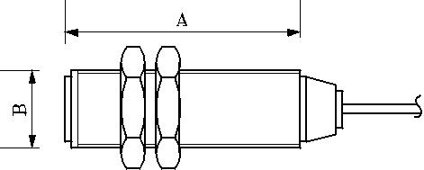
Technical data

Measuring range: 10....50.000 rpm
Operating distance : 0...2 mm
Operating temperature : 0°....+ 60°C

Housing : chromate brass M12 (B) x 35 mm (A)
Cable length : 3 m

Binding Union srl – via Cuorgnè, 21 – 10156 Torino – Italy – tel. +39.011.2625414 – Fax +39.011.2625428 –www.binding.it – 28

INDICATORS
RPM - Portable optical and contact tachometers
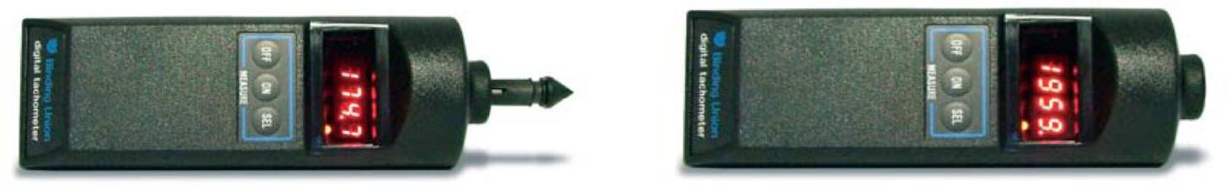

Digital tachometers for measuring angular and linear velocity.

Optical models are suitable for applications where the instrument cannot have physical contact with the moving object or must avoid any braking effect. Contact models make contact with the moving parts via rubber tips or measuring wheels. Their compact size, shock-resistant case and easy operation make these tachometers well suited for all industrial and marine environments (e.g. engine room)

Technical specifications

- Optical or contact monitoring of rpm

- Equipped with a complete set of accessories and plastic case

- Can be coupled with external probes (8406 and 8455 models)

- Total read value function

- Display-hold of last measured value

- Display steps: 19999 or 99999

- Display: 4-digit or 5-digit, 7.6 mm (0.3”) red LED display

- Stability: ±0.015% / °C (max)

- Working distance ranges (optical models): 10…300 m m

- Power supply: 4 x AA batteries 1.5 V (provided)

- Battery life: ≥ 20 hours

- Low battery warning

- Dimensions: 60x185 mm, black ABS

- Weight: ~ 400 g (including battery)

Models | Function | Notes | Accuracy
8404 | Optical tachometer 2…20000 rpm | Provided with case and set of reflectors
8406 | Optical tachometer 2…100000 rpm | Provided with case and set of reflectors | ±0.1 rpm up
 |  | Connector for external probes. | to
8433 | Contact tachometer 2…20000 rpm | Provided with case and rubber tip set | 999,9 rpm
 | 0.02...2000.0 ft/min |  | And
8440 | Contact tachometer 0.2...20000 rpm | Provided with case and set of reflectors
 |  |  | ±0.005%
 | 0.02...2000.0 m/min 0.02...2000.0 m/s
 |  |  | >1000 rpm
8455 | Contact tachometer 0.2…30000 rpm | Provided with case and rubber tip set.
 | 0.02...2000.0 ft/min | Connector for external probes.

Models | Accessories description | Models | Accessories description
AV0157 | Proximity | AV0159 | Rubber test point set
AV0158 | Reflector set | AV0160 | Wheel for linear measure

Binding Union srl – via Cuorgnè, 21 – 10156 Torino – Italy – tel. +39.011.2625414 – Fax +39.011.2625428 –www.binding.it – 29

TRANSMITTERS
TX73 - Transmitters and signals converters
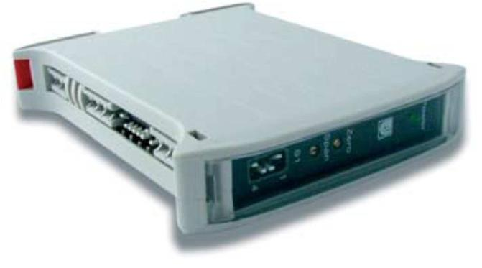

TX73, transmitters/analogical signals converters

Transmitters/converters line of analogical signals in tension, current, frequency and resistance (useful for level measures, temperature, etc.). Galvanic separation between input, output and Power Supply. SMT technology and unique Power Supply both in continue and in alternate. Three programmable outputs (0…10 V, 0 / 4…20 mA), equippe d with two trimmers for fine tuning the retransmitted signal (zero and span). Front LED informs of power presence.

Technical specifications |  | Dimensions
• Precision (at 20°C): ±1%
• Linearity and repetition: 0,25% typical
• | Temperature Coefficient ≤ 0,05%/°C
• Response time: 300 ms
• Voltage output (load ≥100 KΩ): 0…10 V
• Current output (load ≤ 500 Ω): 0 / 4…20 mA
• Power Supply: 10...30 Vdc / Vac 2 W / 3 VA
• Galvanic insulation in/out/p.supply.: 2,3 KVac
• In/out/p.supply Insulation resistance: ≥ 100 MΩ
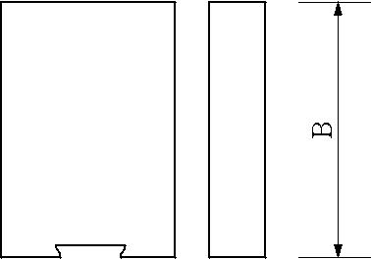
• Electric connections: on screw
- Dimensions: 100 (A) x 22,5 (L) x 120 mm (P)

Models | Input | Notes
731035 | Voltage/current DC, 0...15 V, 0...30 V, 0...60 mV | Suitable to convert the Power Supply line signals coming from
 | (by shunt) | the batteries
732045 | Voltage/current AC, 0...150 V, 0...300 V, 0...5 A | Suitable to convert the Power Supply line signals coming from
 | direct or from TA | the net
732400 | Alternate tension 0…500 V | Suitable to convert the Power Supply line signals coming from
 |  | the lines 380 V
736600 | Temperature, 0...50°C, 100°C, 200°C | Converts the signal deriving from a thermal resistance PT100
736700 | Temperature, 0...200°C, 400°C, 800°C | Converts the signal deriving from a thermal resistance PT100
738000 | Normalized signals, 0÷10V, 0÷20mA, 4÷20mA | Converts and insulates a normalized signal in another one.
738200 | Signals from Potentiometer 1...50 KΩ | Converts a signal deriving from a linear potentiometer
738500 | Frequency/revolutions 20, 200, 2000, 20000 Hz | Net frequency measure or revolutions number through pick up,
 |  | proximity, optical probes and sensors NPN/PNP. It has a feeder
 |  | for sensors (5 Vdc)
738700 | Level 60/90...0,5/3 Ω | Converts and insulates the signals coming from the tubular level
 |  | probes (compatible VDO)
738800 | Level, pressure 0/3/10...180 Ω | Converts and insulates the signals coming from pressure
 |  | sensors (VDO compatible), level probes or sensors 0/3...180 Ω
738900 | Level 240...33 Ω | Converts and insulates the signals coming from the float level
 |  | probes (compatible Teleflex, Vetus and S.Giorgio SEIN)
739100 | Universal, DC e AC, 0÷15/30 Vdc, 0÷60 mVdc | Universal model that combines all models characteristics 731035
 | 0÷150/300 Vac, 0÷5 Aac | and 732045
Models | Description |  | Models | Options description
K | Power supply 10…30Vcc/ca, isolated (default) |  | 10 | Custom configuration / setup

Binding Union srl – via Cuorgnè, 21 – 10156 Torino – Italy – tel. +39.011.2625414 – Fax +39.011.2625428 –www.binding.it – 30

ACCESSORIES
BINDINO – Intelligent Bilge switches
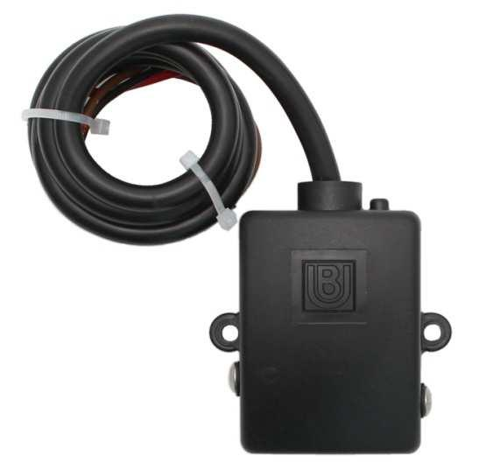

BINDINO, intelligent switches for Bilge pumps

Intelligent electronic switches for Bilge pumps. They allow to keep under control the water presence in the Bilge controlling the suction pump.

They adequate automatically their functioning parameters on the basis of the liquid type, guaranteeing working with every water mixture. They can be fed with any tension included between 10 and 30 Vdc. A condition LED shows the work conditions.

Technical specifications Application

- Microprocessor technology

- Power consumption: min 0,4W (relay on rest), 0,9W (relay excited)

- They adapt to every water mixture

- No part in movement subjected to mechanical blocks

- They avoid pump false priming

- Protection class: IP68

- Power Supply: 10…30 Vdc

- Relay maximum charging: 16A (N.A. type SPST), RPL105 and RPL106

- Relay maximum charging: 1 A in exchange, RPL107 and RPL108

- Delay to the activation: about 10 sec.

- Delay to the disconnection: about 30 sec.

- Operating temperature: 0…60°C

- Dimensions RPL105/107: 82 (A) x 73 (B) x 36mm (C)

- Dimensions RPL106/108: 92 (A) x 73 (B) x 36mm (C)

- Weight: 250 g (with cable by 1 m)
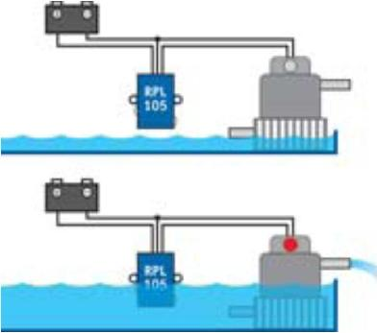
RPL105/107 RPL106/108

Models | Description
RPL105 | Intelligent BILGE switch, relay by 16A
RPL106 | Intelligent BILGE switch, contact lateral lamella (major draft), relay by 16A
RPL107 | Intelligent BILGE switch, relay by 1A in exchange
RPL108 | Intelligent BILGE switch contact lateral lamella (major draft), relay by 1A in exchange

Binding Union srl – via Cuorgnè, 21 – 10156 Torino – Italy – tel. +39.011.2625414 – Fax +39.011.2625428 –www.binding.it – 31

ACCESSORIES
SHUNT
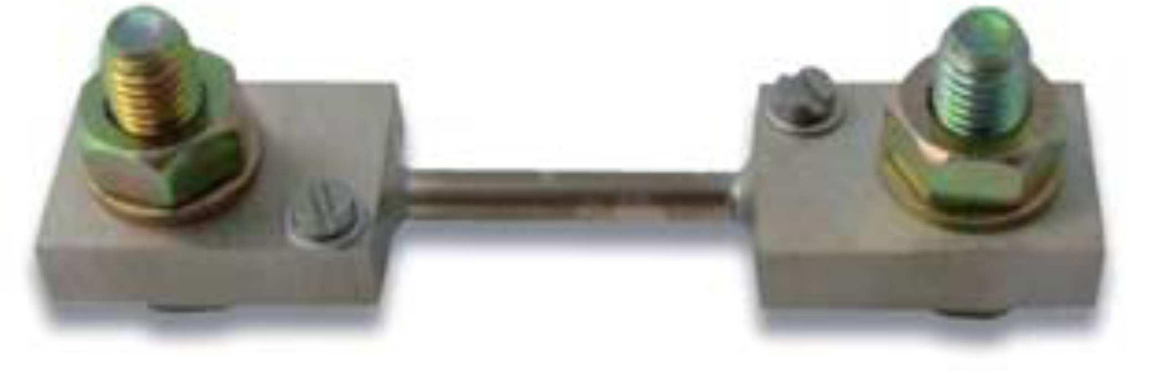

SHUNT

Shunts for measuring direct current. Output from 60mV or 100 mV

Technical specifications

- High accuracy

- Nickel plating

- Made of manganin

- Mounting on insulated base for current up to 60 A

- Dissipation: 0,6 W/A

- Overload: 1.2 ln, continuous operation - 10 In, for 5” (up to ASH250 model) 5 In, for 5” (upper models)

- Output in mV: on screw M4 with washers

- Current input: up to 60 A with bolts M6, over 60 A with bolts M10

- Notes: on request productions from 1 to 6000 A

Description

Models | Capacity | Voltage drop | Class
ASH006 | 6A | 60mV | 0,5
ASH010 | 10A | 60mV | 0,5
ASH020 | 20A | 60mV | 0,5
ASH025 | 25A | 60mV | 0,5
ASH060 | 60A | 60mV | 0,5
ASH100 | 100A | 60mV | 0,5
ASH101 | 100A | 100mV | 0,5
ASH151 | 150A | 60mV | 0,5
ASH250 | 250A | 60mV | 0,5
ASH400 | 400A | 60mV | 0,5
ASH600 | 600A | 60mV | 0,5

Fig.1
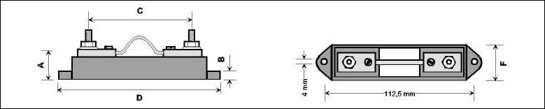
Dimensions (mm)

Fig. | A | B | C | D | F
1 | 23 | 7 | 78 | 123 | 27
1 | 23 | 7 | 78 | 123 | 27
1 | 23 | 7 | 78 | 123 | 27
1 | 23 | 7 | 78 | 123 | 27
1 | 23 | 7 | 78 | 123 | 27
2 | 10 | 36 | 86 | 112 | 25
2 | 10 | 36 | 114 | 138 | 25
2 | 10 | 38 | 86 | 112 | 25
2 | 10 | 38 | 86 | 112 | 25
2 | 10 | 40 | 86 | 117 | 38
2 | 20 | 60 | 131 | 173 | 48

Fig.2

Binding Union srl – via Cuorgnè, 21 – 10156 Torino – Italy – tel. +39.011.2625414 – Fax +39.011.2625428 –www.binding.it – 32

ACCESSORIES
CT – Current transformers
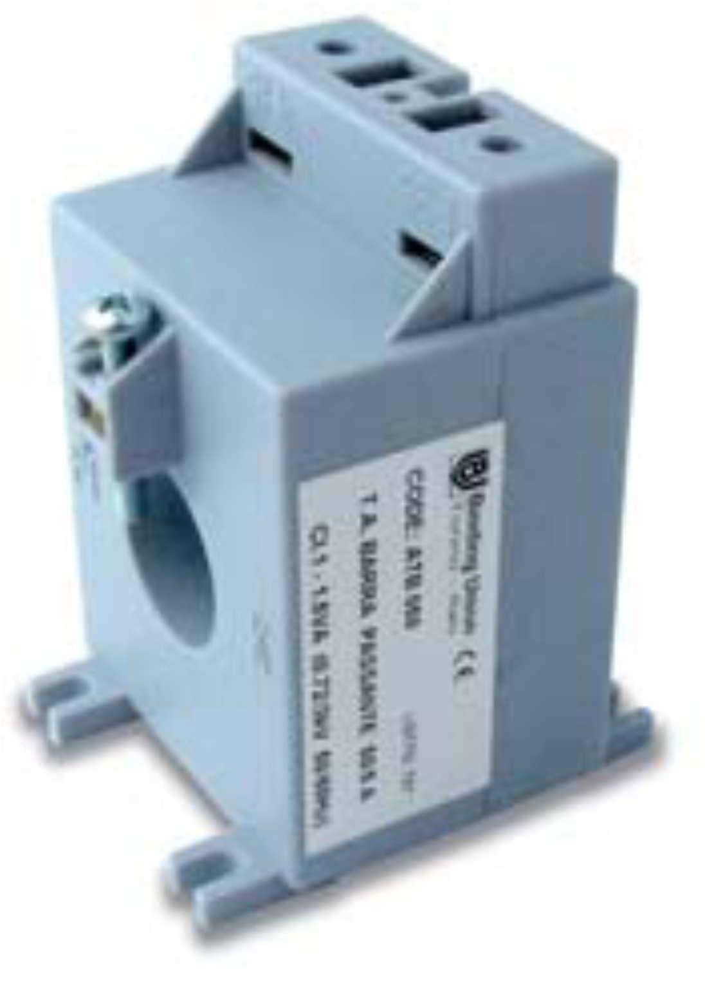

CT, current transformers

Transformers for the alternated current measure.
Suitable for transmitters and current meters.

Rail DIN mounting. Output value 5 A.

Technical specifications

- Wound Primary or Without Primary Models

- Self-extinguishing thermoplastic case with wall fixing pins and snapon 35 mm DIN rail

- Dry-insulation in air

- Integrated execution of the case and secondary cover

- Protection class of terminals: IP20

- Input frequency 50...60 Hz

- Rated secondary current 5 A

- Rated short-circuit thermal current 100 In

- Max insulation voltage 0.6 KV

- Compliant with CEI standards and IEC recommendations

Wound Primary

Models | Primary | Secondary | Class | VA | Weight | Height | Width | Depth
ATA020 | 20A | 5A | 0,5 | 5 | 300 g | 57 | 84 | 70
ATA025 | 25A | 5A | 0,5 | 5 | 300 g | 57 | 84 | 70
ATA050 | 50A | 5A | 0,5 | 5 | 300 g | 57 | 84 | 70
ATA150 | 150A | 5A | 0,5 | 10 | 500 g | 110 | 110 | 80
 |  | Without Primary ( from 30x10mm or diameter 22mm)
Models | Primary | Secondary | Class | VA | Weight | Height | Width | Depth
ATB050 | 50A | 5A | 1 | 1,5 | 260g | 56 | 86 | 62
ATB100 | 100A | 5A | 1 | 2 | 270g | 56 | 86 | 62
ATB150 | 150A | 5A | 1 | 2 | 280g | 56 | 86 | 62
ATB250 | 250A | 5A | 1 | 7 | 350g | 56 | 86 | 62

Binding Union srl – via Cuorgnè, 21 – 10156 Torino – Italy – tel. +39.011.2625414 – Fax +39.011.2625428 –www.binding.it – 33

ACCESSORIES
VARIES
Model ATRLM1 - Temperature probe |  |  |  |  |  |  |  |  |  |  |  | Type |  |  |  |  |  |  |  |  |  |  |  |  |  | Dimensions |  |  |  |  |  |  |  |  |  | Notes
Range: -10…+400°C - Thermoresistance |  |  |  |  |  |  |  |  |  | 3 wire |  |  |  |  |  |  |  |  |  |  |  |  |  |  | A: 3000 mm |  |  |  |  |  |  |  |  |  |  | not suitable
EES = Shielded Silicon Glass - sheath AISI 316
 |  |  |  |  |  |  |  |  |  | PT100 |  |  |  |  |  |  |  |  |  |  |  |  |  |  |  | B: 100 mm |  |  |  |  |  |  |  |  |  | for humid
 |  |  |  |  |  |  |  |  |  |  |  |  |  |  |  |  |  |  |  |  |  |  |  |  |  |  |  | C: 6 mm |  |  |  |  |  |  |  | ambient
Model AV0361 - Temperature probe |  |  |  |  |  |  |  |  |  |  |  | Type |  |  |  |  |  |  |  |  |  |  |  |  |  |  |  |  |  |  |  |  |  |  |  | Notes
Range: 0…+100°C - Silicone Wire |  |  |  |  |  |  |  |  | LM35D |  |  |  |  |  |  |  |  |  |  |  |  |  |  |  |  |  |  |  |  |  |  |  |  |  |  | To be used
 |  |  |  |  |  |  |  |  | Sensor |  |  |  |  |  |  |  |  |  |  |  |  |  |  |  |  |  |  |  |  |  |  |  |  |  |  | with model
 |  |  |  |  |  |  |  |  |  | 3 wire |  |  |  |  |  |  |  |  |  |  |  |  |  |  |  |  |  |  |  |  |  |  |  |  |  | PICO
 |  |  |  |  |  |  |  |  |  |  |  |  |  |  |  |  |  |  |  |  |  |  |  |  |  |  |  |  |  |  |  |  |  |  |  | 1569-T
Model AV0157 - Proximity
Proximity magnetic probe to detect rotation speed, with help of
one or more marks on the moving part.
Specifications
Measuring range: 0...100000 rpm
Sensitivity: 0...1 mm
Operating temperature: 0...60°C
Case: chromed brass M12 (B) x 35 mm (A), Cable length: 3 m
Model AV0158 - Reflector set
Adhesive strips of reflective material to be used wit h optical
sensors (AV0156) and portable optical tachometers.
The kit includes 5 strips of 25 x 90 mm.
Model AV0159 - Rubber test point set
Rubber test points for contact probe (AV0162) and portable
contact tachometers (8433, 8440 and 8455).
To be inserted on metallic shaft (not provided)
Model AV0160 - Linear measurement wheel
Wheels for linear speed detection, to be jointly used with
contact probes (AV0162) and portable contact tachometers
(8433, 8440 and 8455). 20 mm shaft (*)
Model AV0316 – Protection, suitable for lines METER and MICRO | Model AV0314 – Adapters, suitable for the FAST line
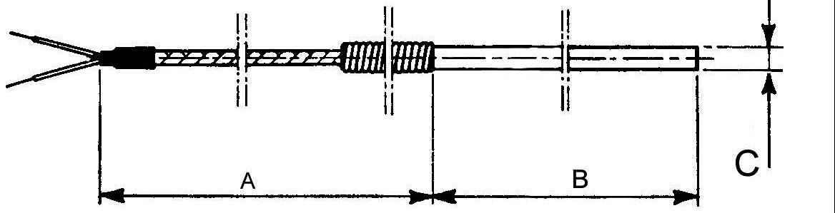
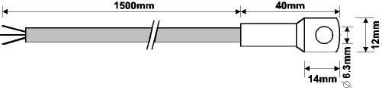
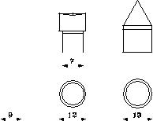
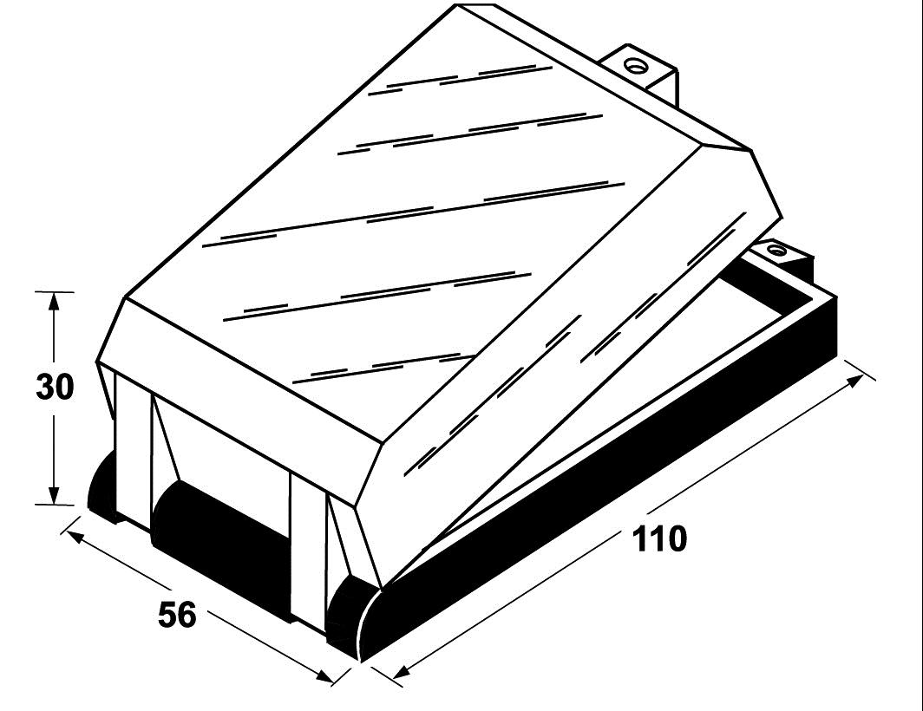
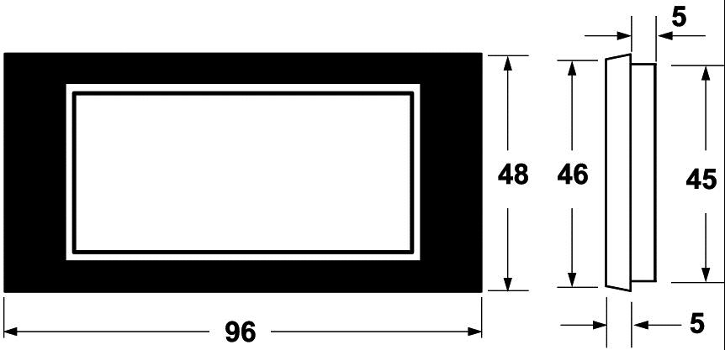

Model AV0311 – Adapters, suitable for the FAST line Model AV0306 – Protection, suitable for the FAST line

Binding Union srl – via Cuorgnè, 21 – 10156 Torino – Italy – tel. +39.011.2625414 – Fax +39.011.2625428 –www.binding.it – 34

ACCESSORIES
VARIES

Magnetic switch with changeover contact

They are made of a REED contact and a permanent magnet. They allow to open or close a contact when the magnet approaches. These accessories are ideal to switch on and switch off lamps as for example the lines IRIS, GEMMA, SABA, at the opening of a door
Technical specifications Reed Contact
- Contact in changeover

- Maximum tension: 150 Vdc
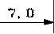
• Maximum activation distance: 15 mm • Maximum power: 3 W
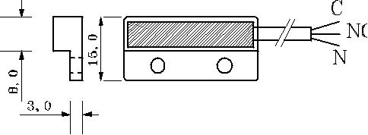
• Cable length: 500 mm
• Colors: C=BI, NC=MA, NO=VE • Protection class: IP66
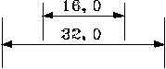
- Dimensions: 32(L)x15(A)x7mm(P)

Model Description

AV0394 Kit, completed, with permanent magnet and reed relay (total dimensions 32x30x7mm)

Line protection

It is a bidirectional diode that offers a high action of blockage and protection against the over tensions. The instantaneous answer to the transitory over tensions makes it particularly suitable to protect all sensible low tension devices as integrated circuits, MOSFET, signal lines and LED lamps.

 | Technical specifications |  |  |  |  |  | Setup diagram
 | • Peak power: 1500 W (10/1000us)
 | • nominal breaking tension scale: 33 V
 | • Block tension and Impulse peak
 |  |  |  |  |  |  | AV0454
 | Max. current: 45,7V-33A @(10/1000us)
 | • Block tension and Impulse peak |  |  |  |  |  |  |  | LAMP
 | Max. current: 59,0V-169A @(8/20us)
 | • Bidirectional type with mitigation low |  |  | 12/24 V
 | factor
 | • Speed answer time
Models | Description |  |  |  |  |  |  |  | Minimum package
AV0454 | Line protection |  |  |  |  |  |  | 10
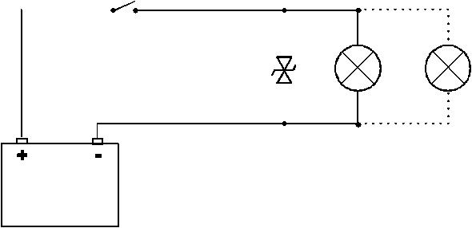
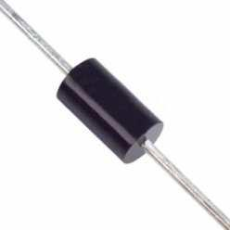
STRIP flexible LED, in roll from 5m, for interiors/exteriors (IP65)
- LED Strip 5 meters

- 60 LED for meter (300 LED in 5 meters)

- Luminosity: 300 lumen/m (White)

- Colors: white, blue, red

- Power consumption: 4,8 Watt, every meter (12V)

- Height: 4 mm (with the terminal plugs 5 mm)

- Width: 10 mm (with the terminal plugs 11 mm)

- Illumination angle: 120° degrees

- Dividable every 3 LED (12V) or 6 LED (24V)

- Power Supply: 12 Vdc (F) or 24 Vdc (G)

Models | Description | Models | Description
CS1105-F | Roll 5 m, Red, 12 Vdc | CS1071 | Terminal plugs for flexible LED strip.
CS1127-F | Roll 5 m, Blue, 12 Vdc | CS1073-F | Junction box with remote control, RGB, 12 Vdc
CS1070-F | Roll 5 m, warm white, 12 Vdc (3000°K) | TL | Length cut, wires registration, on request
CS1067-F | Roll 5 m, cold white, 12 Vdc (6000°K) | G | Option - Power Supply 24 Vdc
CS1072-F | Roll 5 m, RGB, 12 Vdc | AV0454 | Line protection

Binding Union srl – via Cuorgnè, 21 – 10156 Torino – Italy – tel. +39.011.2625414 – Fax +39.011.2625428 –www.binding.it – 35

A few applications in the field

Pico Luxboma
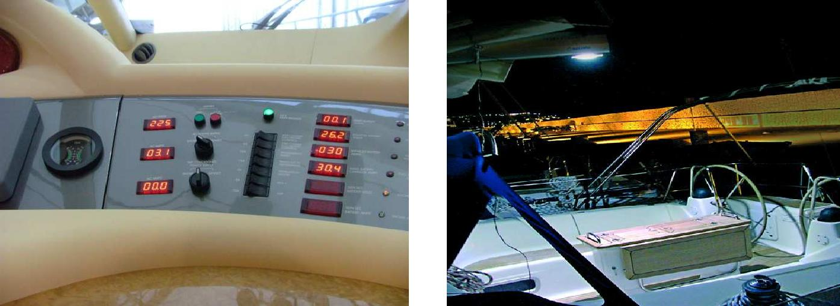

Prisma Iris IE
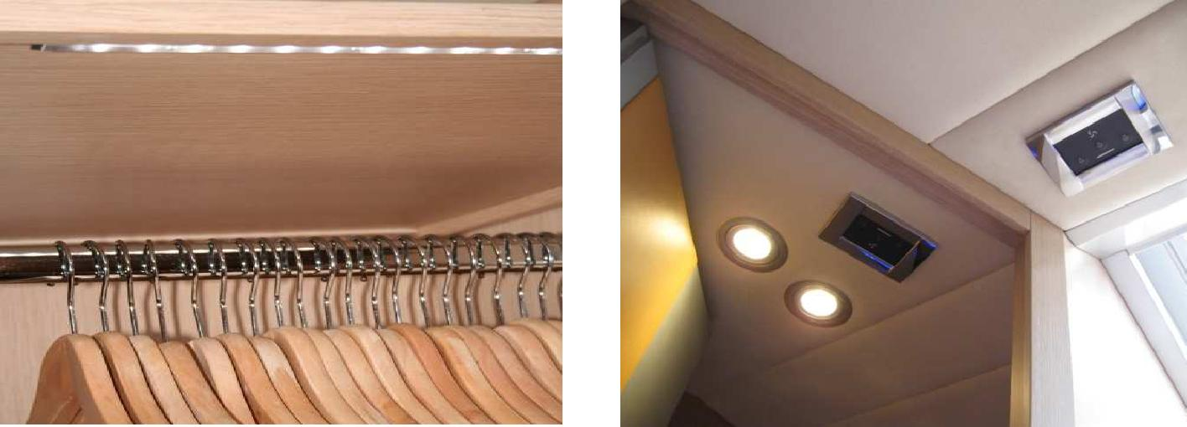

IRIS anti-vandal performance Modular profiles
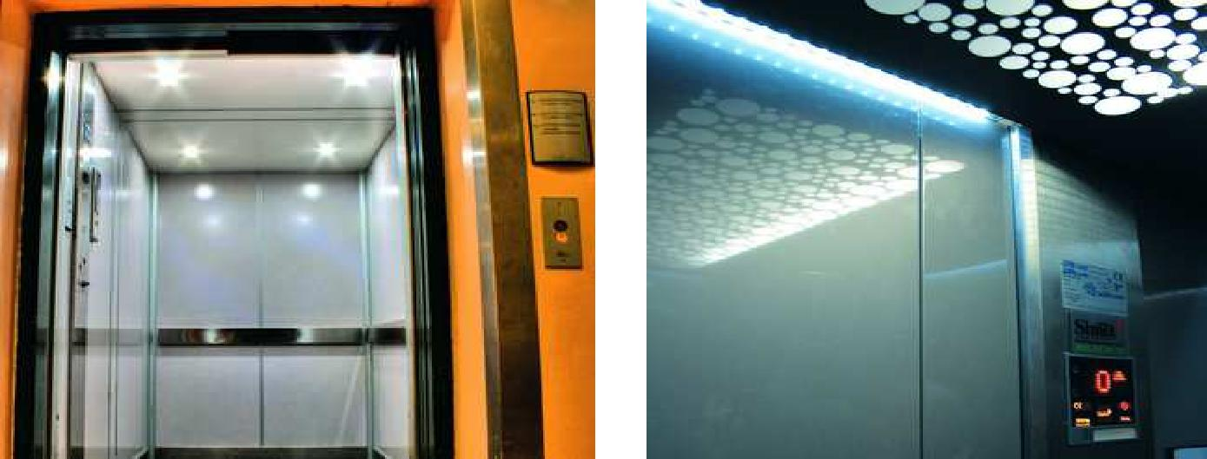

Retailer Promoter

Binding Union srl – via Cuorgnè, 21 – 10156 Torino – Italy – tel. +39.011.2625414 – Fax +39.011.2625428 –www.binding.it – 36

